THE LOOKING GLASS BEAUTY SCHOOL

Lash and Brow Tint and Wax CPD Course — Learner Manual
Course author: Jessica Jane Preston
Document review: Version 1.0 — November 2026 | Review by November 2027 or sooner if law, products or guidance change
Continuing Professional Development (CPD) activity — not a regulated qualification.

Document control and permitted use
This manual has been prepared for The Looking Glass Beauty School's Lash and Brow Tint and Wax CPD Course. It is designed to support qualified beauty professionals in updating and demonstrating safe eyelash and eyebrow tinting and eyebrow shaping knowledge and practical competence. It does not replace product-specific training, an insurer's requirements, local-authority conditions, a Safety Data Sheet (SDS), or medical advice.

Intellectual property, trademarks and images
Every diagram in this pack was drawn specifically for this course and is owned by The Looking Glass Beauty School; each is credited beneath its caption. Brand names are not used to imply endorsement. Where a tutor identifies a product during a live demonstration, the name is used only so learners can follow that product's instructions, mixing ratio, development time and patch-test rule. Product labels, logos, screenshots and third-party photographs must not be copied into the course unless the school holds written permission or a suitable licence.
SCOPE BOUNDARY — This course teaches eyelash tinting, eyebrow tinting and eyebrow shaping by waxing, tweezing and trimming on healthy adult clients. Lash lifting and lamination, brow lamination, henna brows, lash extensions, threading, facial waxing beyond the brow, microblading and permanent make-up are described only so learners can recognise them, work alongside them and refer; this CPD course alone does not qualify a learner to provide them.

Course author
I am Jessica Jane Preston, a qualified beauty and nail professional, beauty educator and salon co-founder with more than fourteen years of industry experience. I hold a VTCT Level 2 NVQ Diploma in Nail Services and an Award in Education and Training, and I provide eyelash and eyebrow tinting and brow shaping to clients at The Looking Glass. Since 2021 I have delivered classroom-based beauty education and have trained more than 400 learners. My CV and qualification certificates are available from the school on request.

Important professional boundaries
- A beauty professional observes, records, adapts, postpones and refers; a beauty professional does not diagnose a disease or prescribe medical treatment.
- A patch test is the client's own test of the exact products you will use, done your way and recorded. It is not optional, it is not transferable between brands, and a negative result does not guarantee that no reaction will occur.
- Do not rely on this manual to override a product label, SDS, manufacturer instruction, local licence condition or insurer instruction.
- Where an urgent reaction includes breathing difficulty, collapse, rapidly increasing facial or throat swelling, or other signs of a medical emergency, call 999. Tint in the eye is irrigated at once and the client is referred if any symptom persists.

Chapter 1 — Course specification and learning journey
What learners can expect, who the course is for, and how competence is assessed

Course title
Lash and Brow Tint and Wax CPD Course
A NOTE ON NAMES — Clients say 'lash tint', 'brow tint', 'brow wax', 'eyebrow shape' and 'HD brows'. The last is a registered trade mark of one company's system and is not used here. This course is titled and advertised as a lash and brow tint and wax course. In teaching and in client records, name the actual tint shade, developer, wax and the development time used, rather than a brand the client happens to know.

Course description
The Lash and Brow Tint and Wax CPD Course is a practical skills-development activity for existing beauty professionals. Learners revisit the anatomy of the skin, the hair and its growth cycle, the eye, the eyelids and the eyebrow, and the conditions that require a treatment to be adapted, postponed or refused; explain how an oxidative tint colours the hair, why it can sensitise and why the patch test is non-negotiable; and learn, through tutor demonstration and supervised practice on each other and on a model, to tint eyelashes and eyebrows safely with the eyes protected, and to map, wax, tweeze and trim the eyebrows to a shape agreed with the client. The course also covers consultation, equipment and product care, UK legal responsibilities, aftercare, emergencies and honest advertising.
Successful completion requires a theory assessment, a directly observed practical assessment and three satisfactory post-course case studies. This activity is Continuing Professional Development and does not replace or confer a regulated beauty qualification.
ONE SUBJECT — Eyelash and eyebrow tinting and eyebrow shaping are taught and assessed together because they are one treatment group in the industry's occupational standards and are booked, consulted for and performed together in salons. The patch test, the eye protection and the consultation are shared; only the last fifteen minutes differ.

Entry requirements and prerequisites
- Learners must be aged 18 or over unless the school's insurer has confirmed an alternative minimum age in writing.
- Learners must hold at least a Level 2 Beauty Therapy or equivalent qualification that includes skin structure and function, facial and eye-area treatments, consultation and safe salon practice. Equivalent prior learning may be accepted subject to provider and insurer approval.
- No previous lash or brow experience is required. Confident, hygienic salon practice is assumed, because the course does not re-teach it.
- Learners must be able to read and follow English-language product labels, Safety Data Sheet information, consultation documents and assessment instructions. Reasonable adjustments are available on request (see the lesson plan and the school's reasonable adjustments policy).
- Learners with a known allergy to hair dye, eyelash or eyebrow tint, para-phenylenediamine (PPD) or black henna must discuss this with the school and their doctor before enrolling, because repeated handling of tint is itself an exposure. Gloves are worn for every tint service.
- Before offering the treatments commercially, learners must confirm that their qualification route, this CPD training and their intended working arrangements are acceptable to their insurer and their local authority.

Duration and delivery structure
The lesson plan for the taught day (document L05 in the Tutor and Assessor Pack) sets out the timetable and matches these hours: 7.5 guided learning hours on the day, 1.5 hours of pre-course reading and about 6 hours of case-study work, 15 hours in all.
Component | Time | Evidence
Pre-course reading and knowledge activity | 1.5 hours | Completed learner workbook prompts (Chapter 19)
Tutor-led classroom and practical day | 7.5 guided learning hours, excluding breaks | Attendance, questioning and direct observation
Three post-course case studies | Approximately 6 hours total | Consultation, patch test record, treatment record, photographs with consent, reflection and educator feedback
Total learner effort | Approximately 15 hours | All evidence retained in the learner portfolio

Learning outcomes
- LO1 — Explain what eyelash and eyebrow tinting and eyebrow shaping are, their benefits and limitations, who they suit and when another service or a referral is the honest answer.
- LO2 — Describe the structure and growth cycle of the hair, the skin of the eye area and the anatomy of the eye, eyelids and eyebrow, and recognise the conditions that mean a treatment is adapted, postponed or refused.
- LO3 — Conduct and record a professional consultation, carry out and record a patch test, obtain informed consent and agree an individual treatment plan.
- LO4 — Explain how an oxidative tint colours the hair, why it can sensitise, how shade, developer and timing decide the result, and why the products are restricted to professional use and to clients aged 16 and over.
- LO5 — Select, handle, store and dispose of tints, developers, waxes and equipment in accordance with risk assessment, COSHH, manufacturer instructions and current UK requirements.
- LO6 — Prepare the client and the treatment area, protect the eyes and skin, and work hygienically throughout.
- LO7 — Tint eyelashes to an even, natural-looking result with the eyes protected and closed, no tint on the skin and no tint in the eye.
- LO8 — Tint eyebrows to a shade that suits the client, timed and checked, with the skin kept clean.
- LO9 — Map, wax, tweeze and trim the eyebrows to a balanced shape agreed with the client, with the wax temperature tested, the skin supported and the eyelid never waxed.
- LO10 — Provide aftercare, recognise and manage contra-actions, adverse reactions and tint in the eye, and set honest expectations about results and how long they last.

Assessment strategy and pass requirements
Theory: a written paper of 38 questions totalling 50 marks, with partial credit for multi-part questions. The pass mark is 80% (40/50). Any answer that instructs tinting without a recorded negative patch test, tinting a client under 16, tinting with the eyes open, leaving tint in an eye without irrigating, waxing the eyelid, double-dipping a spatula, waxing over a contraindicated area or treating a client with a red, sticky or swollen eye must be corrected before a pass is awarded.
Practical: direct observation on a suitable adult model, requiring at least 80% overall and a pass in every safety-critical criterion.
Case studies: three complete services after the taught day (a lash tint, a brow tint and a brow shape, or combinations that cover all three), each with consultation, patch test record, before and after images where separate consent is held, product record, treatment notes, aftercare and reflection.
Models: learners arrange their own suitable adult model for the practical assessment and confirm this with the school at booking. The model must be aged 18 or over, must have had a negative patch test with the school's tint and developer recorded at least 48 hours before the course (the school offers a patch-test appointment in the week before), must have no contraindication from Chapter 4, and must complete Form A. A model without a recorded negative patch test can be waxed and shaped but not tinted, and the tint element is then assessed on a later date. A learner who cannot bring a model must tell the school at least seven days before the course.
Where the assessment papers are: the theory paper (document L02), its mark scheme (L03) and the practical observation marking sheet (L04) are held in the Tutor and Assessor Pack and are not printed in this manual. The practical is marked on twenty criteria; the seven below are safety-critical and every one must be met for a pass, whatever the overall score:
- A negative patch test for the exact tint and developer, carried out and recorded at least 48 hours before, checked before any tint is mixed; no tint without it, and no tint on a client under 16.
- The client's eyes closed and protected from the first pad to the last wipe; no tint applied to skin; tint in the eye treated as an emergency and irrigated at once.
- Wax temperature tested on the professional's own inner wrist and then on a small area of the client's skin before the first application; no wax on the mobile eyelid.
- A fresh spatula for every dip into the wax; single-use items used once and discarded; tools decontaminated between clients; the blood-spot procedure followed if the skin bleeds.
- Skin held taut for every removal and the wax or strip removed parallel to the skin against the growth; no wax over a mole, skin tag, broken, sunburnt, retinoid-treated or otherwise contraindicated skin.
- The treatment refused or adapted where a contraindication is present; a red, sticky, swollen, crusted or painful eye never treated; nothing diagnosed.
- Hygiene: hands washed, gloves worn for tinting and waxing, the work area and client's skin prepared and protected, waste disposed of correctly.

Chapter 2 — Lash and brow treatments: purpose, benefits and professional scope
Understanding the treatments before learning the technique

What the three treatments are
Eyelash tinting deposits a permanent colour inside the lash hair with an oxidative tint, so that fair, fine or faded lashes look darker, longer and more defined without mascara. The colour stays until the hair is shed, so the effect lasts four to six weeks and fades gradually as the lashes turn over.
Eyebrow tinting does the same for the brow hairs, and because brow hair is coarser and shorter the development is faster and the shade choice matters more. A brow tint also colours the fine, pale vellus hairs that the eye does not normally register, which is why a tinted brow looks fuller as well as darker. On the brow the colour lasts three to four weeks: brow hairs are shed faster than lashes, and anything that touches the skin is lost within days as the skin cells turn over.
Eyebrow shaping removes hair to refine the brow the client already has, by waxing the lines under, between and above the brows, tweezing the stray and fine hairs the wax leaves, and trimming hairs that are too long for the shape. A good shape is decided by the face, the natural growth and the client's wish, in that order, and is mapped before any hair is removed. Hair returns in three to four weeks.
What the treatments are not: they do not make lashes or brows grow, they do not curl or lift the lash, they do not change the direction a brow grows in, and they cannot put hair where the follicles have gone. A client who wants a curl needs a lash lift; one who wants lift, set and a fuller look needs brow lamination; one who wants colour on the skin needs henna or permanent make-up; and every one of those is a separate product, patch test and training.

Benefits and limitations
Potential benefit | Professional limitation
Defined lashes and brows with no daily make-up, for four to six weeks (lashes) and three to four weeks (brows) | Only on hair that is there. Sparse brows look fuller, not full; tint on skin is gone in days and is not the aim.
Waterproof: ideal for holidays, swimming, the gym and clients who cannot wear mascara | Oil-based cleansers, exfoliating acids and strong sun fade the colour faster. Say so in the aftercare.
Quick: fifteen to forty minutes depending on the combination | The patch test is a separate visit at least 48 hours before the first tint, with every new brand, and after a six-month gap.
A tidy, balanced brow lifts the whole face | The brow is refined, not redrawn. Over-plucked brows need months to regrow; nothing you do makes that faster.
Safe and predictable when the products are made for the purpose | Only professional eyelash and eyebrow tints with their own developer. Hair dye is never used near the eye.
Suits almost every adult client | Not clients under 16 (tint), not an eye that is red, sticky, swollen or sore, not skin that is broken, sunburnt or thinned by medication.

Who the treatments may suit
- A client with fair, red, grey or fine lashes or brows who wants definition without daily make-up.
- A client who swims, trains, travels or works long hours and wants to wake up looking groomed.
- A client whose brows have grown back after years of over-plucking and who wants them shaped rather than reduced.
- A client who wears contact lenses and finds mascara irritating, provided the lenses come out for a lash tint.
- A client whose consultation and patch test reveal no active contraindication.

When another service or a referral may be more appropriate
- A lash lift, with or without tint, suits a client whose lashes are dark but straight and who wants curl and length.
- Brow lamination suits a client with unruly or downward-growing brow hair who wants it set upward and full.
- Henna brows or permanent make-up suit a client who wants colour on the skin where there is little hair; both are separate products and separate training.
- Lash extensions suit a client who wants length and volume the natural lash cannot give; tint is not applied over extensions.
- No cosmetic treatment of any kind should be used on an eye or skin condition, to hide one, or on a client who has reacted to hair dye or black henna. A pharmacist, optician or GP is the right referral.

Comparing the related treatments
Treatment | What it changes | Product and patch test | Lasts
Lash tint (this course) | Colour of the lash hair | Oxidative tint and developer; patch test at least 48 hours before | 4 to 6 weeks
Brow tint (this course) | Colour of the brow hair and fine vellus hair | Oxidative tint and developer; patch test at least 48 hours before | 3 to 4 weeks
Brow shaping (this course) | Removes hair to refine the natural shape | Wax, tweezers, scissors; wax temperature test on the day | 3 to 4 weeks
Lash lift | Curl and direction of the lash | Thioglycolate-based lifting and setting lotions; patch test | 6 to 8 weeks
Brow lamination | Direction and set of the brow hair | Thioglycolate-based lotions; patch test | 4 to 6 weeks
Henna brows | Colour on hair and a stain on the skin | Henna-based powder; patch test | Skin 1 to 2 weeks, hair up to 6
Threading | Removes hair by twisted cotton | No product | 3 to 4 weeks
NAME THE PRODUCT — A tint, its matching developer, the mixing ratio and the development time from one manufacturer are a tested system that has passed the safety assessment required of a cosmetic product. Mixing one brand's tint with another's developer, or with a stronger hairdressing peroxide, is an untested experiment next to a client's eye. Record the actual products, shades and batch numbers on every client card.

Where lash and brow treatments came from
Darkening the lashes and shaping the brows are among the oldest grooming practices there are. Kohl, made from ground minerals, lined the eyes and darkened the lashes of men and women in ancient Egypt; Roman writers describe women darkening lashes and brows with soot and antimony. Brow fashions have swung between extremes ever since: plucked high and thin in Elizabethan England and again in the cinema of the 1920s and 1930s, full and groomed in the 1950s, arched and heavy in the 1980s, thin again in the 1990s, and full once more from the 2010s, when a generation that had over-plucked turned to the salon for shaping, tinting, lamination and microblading to repair the damage.
The products changed slowly and then quickly. Commercial mascara dates from the nineteenth century (Eugène Rimmel's name is still a word for it in several languages) and the familiar tube and wand from the mid-twentieth. Salon eyelash and eyebrow tinting followed the development of the oxidative dyes used on scalp hair, reformulated at lower strength for use near the eye; by the 1970s and 1980s brow waxing and tinting were standard salon services across the UK. The modern regulatory position, in which specific dye substances are permitted for professional use on the lashes and brows with mandatory warnings, dates from the European cosmetics legislation that the UK has retained since 2021. The treatments have outlasted every brow fashion because they solve the same everyday problem: definition that does not wash off.

Service time, pricing and promotion
A brow wax commonly takes fifteen minutes; a brow tint fifteen to twenty; a brow wax and tint together twenty-five to thirty; a lash tint thirty to forty, most of which is development time; a lash and brow tint together about forty-five. Price each service on your time, product cost and your market, not on what a competitor charges. The points below are a starting framework; set your own figures.
- Patch test: free or nominal, booked as its own short appointment at least 48 hours before the first tint. A free patch test that saves a reaction is the cheapest insurance you will ever buy.
- Combination pricing: wax and tint, or lash and brow tint, priced below the sum of the parts, because the consultation, set-up and protection are shared.
- Shaping maintenance: a lower price for a rebook within four weeks, when there is less to remove and the shape is only being kept.
- Add-ons: a brow trim and tidy with a tint; a lash tint with a facial. Never an add-on that needs a patch test the client has not had.
Promotion that works: photograph every brow from the front with the face relaxed, in the same light before and after, with consent; the picture other professionals notice is the balanced pair, not the dramatic single brow. Describe the services honestly in line with Chapter 10 (defined, waterproof colour; never 'permanent' or 'semi-permanent mascara'). Book the next shape or tint at the end of every appointment, three to four weeks ahead for brows and four to six for lashes. Tell clients plainly who the treatments are for and who they are not for; the client who leaves with the right service, or the right referral, is the one who comes back.

Chapter 3 — Anatomy and physiology: the skin, the hair, the eye and the eyebrow
The structures you are working on and the ones you must protect

The skin
The skin is the body's largest organ. It protects, regulates temperature, senses, excretes, secretes sebum and sweat, absorbs a little and makes vitamin D. For this course three facts about it matter more than any list of functions. First, the epidermis renews itself from the basal layer upward in about four weeks and sheds continuously, which is why tint on the skin disappears within days while tint in the hair lasts until the hair falls. Second, the skin of the eyelid is the thinnest on the body, about half a millimetre, with very little fat beneath it, which is why it bruises, swells, lifts and burns more easily than the skin of the brow, and why the eyelid is never waxed. Third, the skin's acid mantle and intact surface are its barrier; anything that has thinned or broken that barrier (sunburn, retinoids, peels, eczema, a scratch) makes a wax lift the skin and a tint sting.
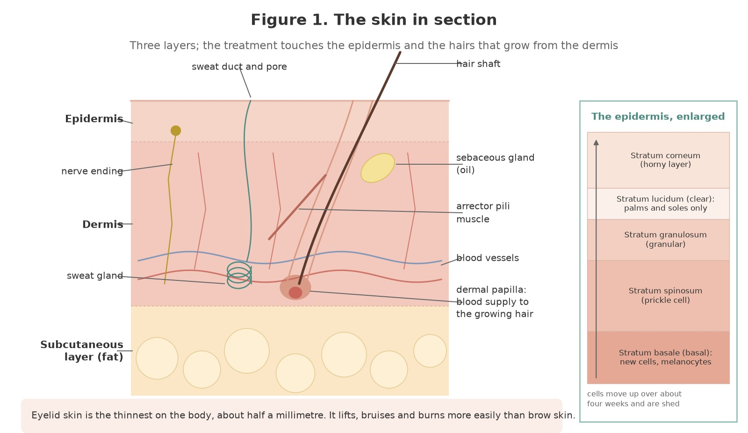
Figure 1. The skin in section: the epidermis with its five layers (enlarged on the right), the dermis with the hair follicle, sebaceous gland, arrector pili muscle, sweat gland, blood vessels and nerve endings, and the subcutaneous fat. Eyelid skin is the thinnest on the body.
Original illustration © The Looking Glass Beauty School, 2026.
Structure | What it is | Why it matters to you
Epidermis | The outer, bloodless layer: stratum basale (new cells, melanocytes), spinosum, granulosum, lucidum (palms and soles only) and corneum (the dead, flattened surface cells) | Tint on the skin sits in the stratum corneum and is shed in days. A wax pulls off some corneum every time; a second pass on the same spot pulls off more than it should.
Dermis | The living layer beneath: collagen and elastin, blood and lymph vessels, nerve endings, hair follicles, sebaceous and sweat glands | Pain, redness and blood spots after waxing come from here. Erythema is the dermis dilating its vessels in response to the pull.
Subcutaneous layer | Fat and loose connective tissue | Almost absent on the eyelid, so the lid has no cushion against pulling, pressure or heat.
Sebaceous gland | Opens into the follicle and oils the hair and skin | Sebum stops tint taking evenly and stops wax gripping. Both treatments start with an oil-free cleanse.
Acid mantle | The slightly acid film of sebum and sweat on the surface | Alkaline tint mixtures and waxing disturb it; aftercare is partly about letting it recover.
Melanocytes | Pigment cells in the basal layer | Darker skin types are more prone to post-inflammatory hyperpigmentation after a wax that lifts or burns the skin.

The hair and its follicle
Hair is a filament of keratin, the same protein as the nail and the outer skin. The part you see, the shaft, is dead; the part that matters for growth, the root, sits in a pocket of epidermis called the follicle that reaches down into the dermis. At the bottom of the follicle the bulb surrounds the dermal papilla, a knot of blood vessels that feeds the matrix cells that make the hair. The follicle has its own sebaceous gland and a tiny arrector pili muscle that stands the hair up in cold or fear.
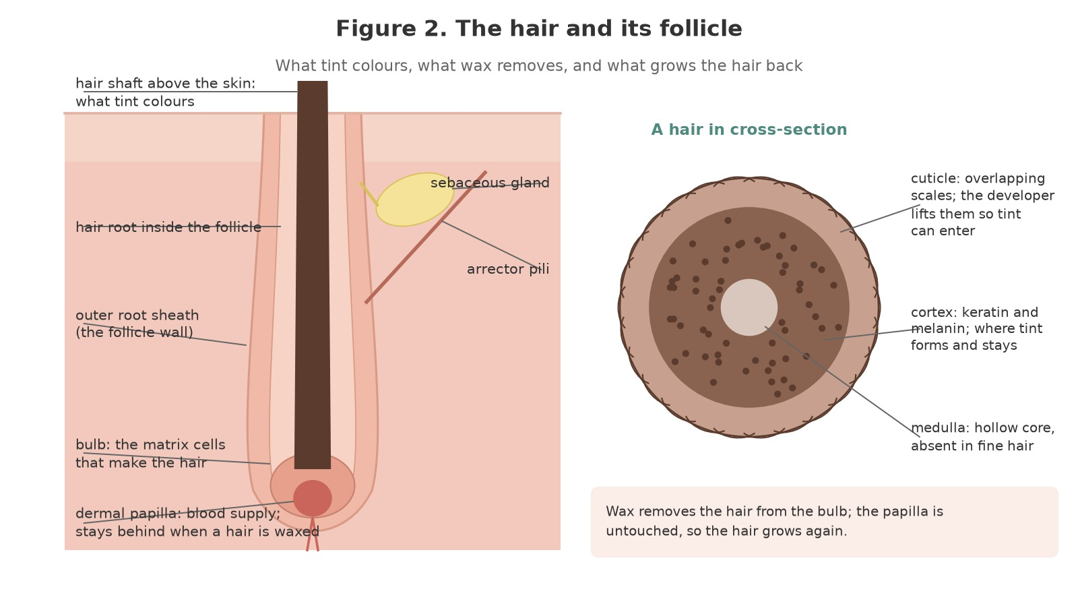
Figure 2. The hair and its follicle. Left: the follicle in section, from the shaft above the skin to the bulb and dermal papilla below. Right: a hair in cross-section, showing the cuticle that tint must pass through, the cortex where the colour forms, and the medulla.
Original illustration © The Looking Glass Beauty School, 2026.
In cross-section the shaft has three layers. The cuticle is a single layer of overlapping scales, colourless and translucent, that protects the hair; the alkaline tint mixture lifts the scales so the dye can enter. The cortex is the bulk of the hair: keratin fibres and the melanin granules that give the hair its natural colour, and the place where the tint forms and stays. The medulla is a soft, sometimes hollow core that is often absent in fine hair, including most lashes.
Waxing removes the hair from the bulb; tweezing does the same one hair at a time. The dermal papilla stays behind, which is why the hair regrows, and also why repeated removal of the same hair over many years can eventually weaken the follicle and thin the brow: the 1990s brow did not grow back for everyone.

The hair growth cycle
Every follicle runs its own cycle of growth, change and rest, independently of its neighbours. Anagen is the growing phase, when the hair is attached to its papilla and lengthening. Catagen is a short transition when growth stops and the lower follicle shrinks, leaving the hair as a club. Telogen is the resting phase, when the club hair sits loosely in a shortened follicle until a new anagen hair pushes it out. On the scalp anagen lasts years, which is why scalp hair grows long; on the lashes and brows it lasts weeks, which is why they do not.
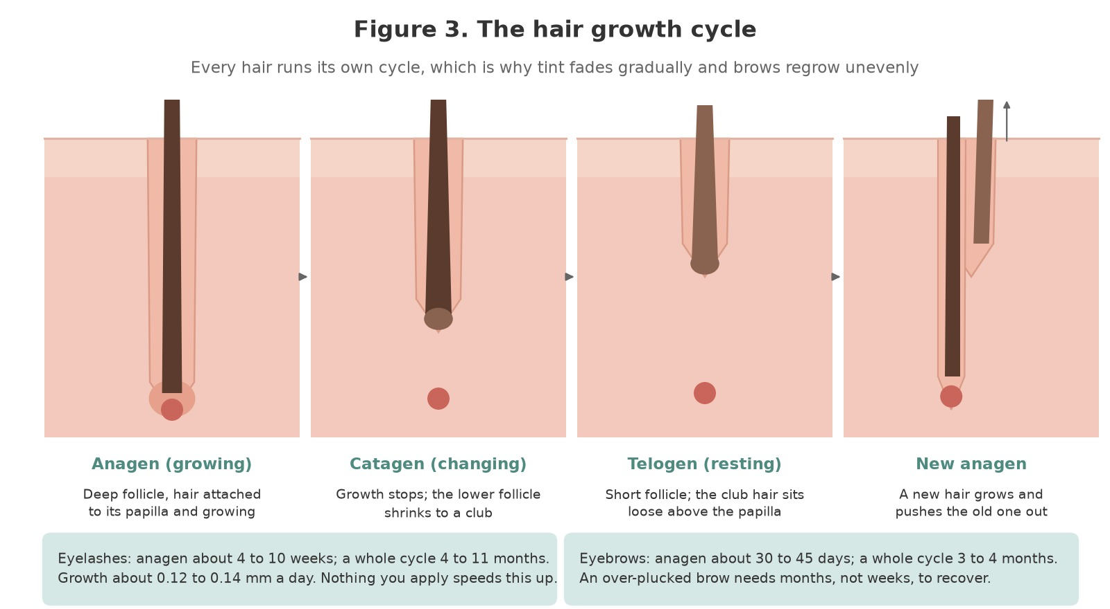
Figure 3. The hair growth cycle: anagen, catagen, telogen and the new anagen hair pushing out the old. Lashes and brows have a short anagen, so they stay short and are replaced every few months.
Original illustration © The Looking Glass Beauty School, 2026.
Structure | What it is | Why it matters to you
Eyelash cycle | Anagen about four to ten weeks; the whole cycle about four to eleven months; growth about 0.12 to 0.14 mm a day | A lash tint lasts until the tinted lashes are shed, four to six weeks for a noticeable fade. Nothing in a tint affects growth; a client who loses lashes after a tint has reacted to it, not 'lost them to the chemicals'.
Eyebrow cycle | Anagen about 30 to 45 days; the whole cycle three to four months | Brow regrowth after shaping shows in three to four weeks. An over-plucked brow needs three to four months to recover fully, and a follicle that has been repeatedly emptied for years may not.
Vellus hair | Fine, short, pale hair over most of the body and around the brow | Brow tint colours vellus hair, which is why a tinted brow looks fuller and why you cleanse off every trace of tint from the skin around the shape.
Terminal hair | Coarse, pigmented hair: scalp, brows, lashes, beard | Coarse brow hair takes tint fast (one to three minutes) and grips wax well; fine fair hair takes longer.
Growth direction | Brow hairs grow up at the head, along the arch and down and out at the tail | Wax is applied with the growth and removed against it. Tweeze in the direction of growth to avoid breaking the hair.

The eye and the eyelids
The eyeball sits in the bony orbit, protected by the eyelids, the lashes, the brow and the tear film. The eyelids are folds of skin, muscle and a stiffening plate of connective tissue called the tarsal plate, lined on the inside by the conjunctiva, a clear membrane that continues over the white of the eye. The orbicularis oculi muscle in the lid closes the eye and, when the client squeezes, pushes anything on the lid margin toward the eye: a client who screws the eyes shut during a lash tint is more likely to get tint in the eye, not less. Ask for closed, relaxed eyes.
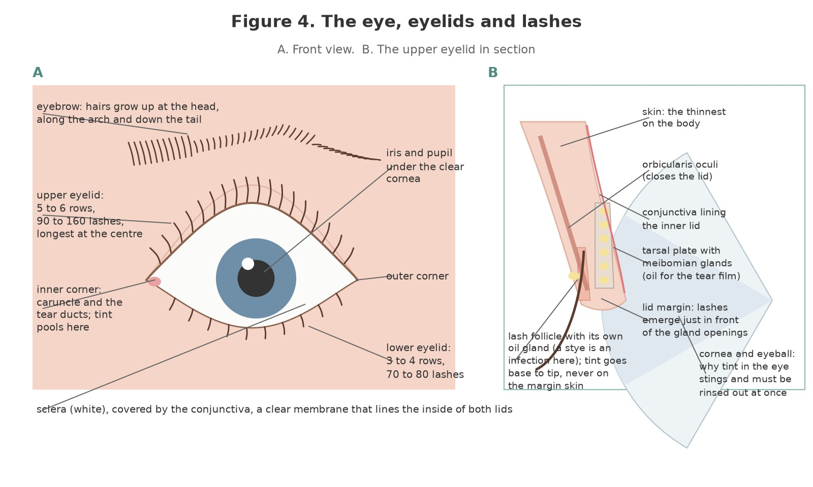
Figure 4. The eye, eyelids and lashes. A: front view, with the lash rows, the inner corner where tint pools and the conjunctiva over the white of the eye. B: the upper eyelid in section, with the tarsal plate and its glands, the lash follicle and the margin where lashes emerge.
Original illustration © The Looking Glass Beauty School, 2026.
Structure | What it is | Why it matters to you
Upper eyelid lashes | Five or six irregular rows, about 90 to 160 lashes, longest at the centre, curving upward | Tint from the base to the tip with the eye closed; the pad underneath catches the tint that would otherwise reach the lower lid skin.
Lower eyelid lashes | Three or four rows, about 70 to 80 shorter lashes, curving downward | Tinted first, over the pad, so that any transfer is on the pad and not on the cheek.
Lid margin | The edge of the lid where the lashes emerge, with the openings of the meibomian glands behind them | The margin is skin; tint on it stings and stains. The applicator works on the hair, a hair's breadth from the margin.
Meibomian glands, glands of Zeis and Moll | Oil and sweat glands of the lid margin and lash follicles | A stye is an infection of a lash follicle's gland; a chalazion a blocked meibomian gland. Both mean no treatment on that eye.
Conjunctiva | The clear membrane lining the inside of the lids and covering the white of the eye | Conjunctivitis is its inflammation: red, sticky, watering. Highly infectious; refuse and refer.
Cornea | The clear dome over the iris and pupil | Tint or developer on the cornea is a chemical injury. Irrigate at once; refer if any symptom persists.
Inner corner | The caruncle and the tear ducts (puncta) that drain tears to the nose | Tint and water pool here. Wipe outward, away from the ducts, and dry the corner before the client opens the eye.
Tear film | Oil, water and mucus layers that protect and lubricate the eye | Watering is the eye's defence against an irritant: a client whose eyes stream throughout a tint is reacting to fumes or product. Pause, lift the lids' corners with a dry pad, and reassess.

The eyebrow and the muscles that move it
The brow is a band of coarse hair over the bony ridge of the frontal bone that keeps sweat and light out of the eye and is the face's most expressive feature. It has a head (or bulb) nearest the nose, where the hairs grow upward; an arch or peak, where they grow along the brow; and a tail, where they grow down and outward. Four muscles move it. Frontalis, in the forehead, raises the brow. Orbicularis oculi, the ring around the eye, closes the lids and draws the brow down. Corrugator supercilii pulls the brows together and down, making the vertical frown lines. Procerus pulls the head of the brow down, making the horizontal line at the bridge of the nose. Every one of them changes the position of the brow by a centimetre or more, so brows are mapped and checked with the face relaxed and the client looking straight ahead.
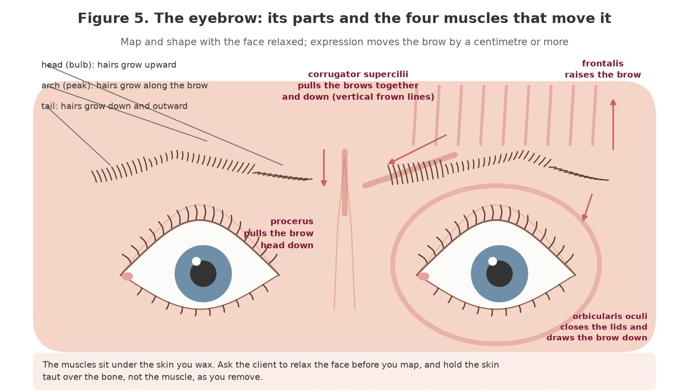
Figure 5. The eyebrow: head, arch and tail with their hair directions, and the four muscles that move the brow: frontalis, orbicularis oculi, corrugator supercilii and procerus. Map and shape with the face relaxed.
Original illustration © The Looking Glass Beauty School, 2026.

Factors that influence the lashes and brows
Factor | Effect | Professional response
Age | Brow hairs become coarser, longer, straighter and greyer; lashes thinner and paler; eyelid skin thinner and looser | Trim more, tint lighter shades (graphite or light brown for grey), support the skin firmly, consider tweezing instead of wax on very thin skin
Hormones | Pregnancy, the menopause, thyroid disease and polycystic ovary syndrome change hair growth and skin sensitivity | A new patch test; shaping only on hair the client wants gone; never comment on cause
Medication | Isotretinoin, topical retinoids and steroids thin the skin; chemotherapy thins or removes brows and lashes; anticoagulants increase bruising | Chapter 4: wait, adapt or refuse; GP advice where stated
Over-plucking and previous waxing | Thinned brows, gaps, follicles that have stopped producing | Tint to fill visually; shape only within the hair that exists; honest expectations about regrowth
Skin type | Darker skin is more prone to post-inflammatory hyperpigmentation after a lift or burn; very fair skin shows erythema longer | Perfect temperature and technique; a cool compress; aftercare that includes sun protection
Habit | Rubbing the eyes, sleeping face-down, mascara removed roughly | Aftercare advice; a client who loses lashes to rubbing is not losing them to tint

Chapter 4 — Skin and eye conditions, contraindications and recognition
Observe, ask, decide, record, refer
FOUR-STEP DECISION — OBSERVE the eyes, the lids, the brow skin and the surrounding face in good light before anything is applied. ASK when it began, whether it hurts, itches or weeps, and whether it is changing. DECIDE to proceed, adapt, postpone or refer; never diagnose. RECORD what you saw and what you decided, in the client's words and yours.
A contraindication is a condition or circumstance that makes a treatment unsafe, or unsafe without adaptation. Some are absolute for the eye area (an eye infection), some apply to one treatment and not another (a retinoid stops the wax, not the tint), and some are a matter of timing (sunburn heals). The table lists the conditions a lash and brow professional sees most. It is not a diagnostic guide; the column that matters is the last one. If the client is told why you are not treating them, kindly and without a diagnosis, and is pointed to the right person, they come back.

Eye and eyelid conditions
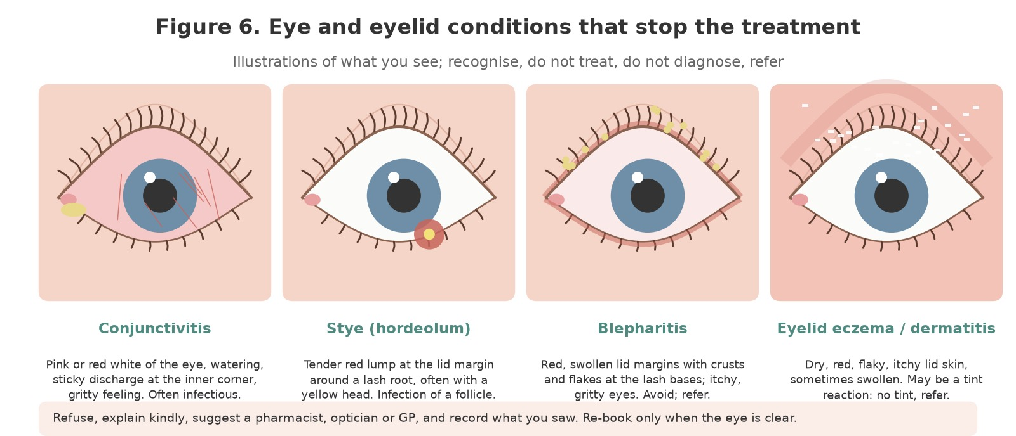
Figure 6. Four eye and eyelid conditions that stop the treatment, as illustrations of what you see: conjunctivitis, a stye, blepharitis and eyelid eczema or dermatitis. Recognise, refuse kindly, refer; never diagnose.
Original illustration © The Looking Glass Beauty School, 2026.
Condition or finding | What you may see or hear | Professional action
Conjunctivitis | Pink or red white of the eye, watering, sticky or crusted lashes especially on waking, gritty feeling; one or both eyes | No treatment to either eye. Highly infectious: decontaminate anything the client touched. Pharmacist or GP.
Stye (hordeolum) | Tender red lump at the lid margin at a lash root, often with a yellow head | No treatment to that eye until fully resolved; no squeezing; pharmacist.
Chalazion | Painless firm lump in the lid, away from the margin, from a blocked gland | No tint or wax over or near it; refer to the GP if it persists.
Blepharitis | Red, swollen, crusted lid margins, flakes at the lash bases, itchy gritty eyes; often long-standing | No lash tint; brow services only if the brow skin is clear. Advise lid hygiene via a pharmacist or optician.
Dry eye, watery eye, hay fever, a cold | Streaming, itching, red rims, frequent blinking | Postpone a lash tint until the eyes are settled; a brow service may go ahead.
Recent eye surgery, laser eye surgery, eye injury | Client reports it; redness, sensitivity | No eye-area treatment until the surgeon or optician has cleared it, commonly four to six weeks for laser surgery and longer for other surgery.
Contact lenses | Client wears them | Out before a lash tint and until the eye is dry and comfortable afterward; the client brings a case and solution.
Lash extensions | Synthetic lashes bonded to the natural lashes | No lash tint: the adhesive and fibres do not tint and the solvents in a tint can weaken the bond. Refer to the extension technician.
Recent lash lift or brow lamination | Client reports it within the last 48 hours | Follow that product's rules on tinting; if in doubt wait 48 hours. Not taught here.

Skin conditions in the treatment area
Condition or finding | What you may see or hear | Professional action
Eczema or dermatitis | Dry, red, flaky, itchy, sometimes cracked or weeping skin on the lids or brow | No tint or wax on affected skin. Weeping or cracked skin anywhere near the eye: postpone. Eyelid dermatitis after a previous tint is a reaction: no tint again.
Psoriasis | Well-defined red plaques with silvery scale, in the brow or at the hairline | Avoid the plaque; no wax over it; tint only on hair with intact skin beneath. Not infectious.
Cold sore (herpes simplex) | Tingling, then blisters and crusts, usually at the lip but possible near the eye | No facial treatment while active; near the eye, refuse and advise urgent GP or optician advice, because herpes can affect the eye.
Impetigo | Red sores that burst and leave golden-brown crusts, often around the nose and mouth | No treatment anywhere on the face until fully healed and treated. Highly infectious.
Ringworm (tinea) | Ring-shaped scaly patch with a clearer centre | No treatment in the area until treated and clear; decontaminate.
Acne, folliculitis, pustules in the brow | Spots, pustules, inflamed follicles | No wax over active spots; tweeze around them; no tint on broken skin.
Moles, skin tags, warts | Raised or pigmented lesions in or near the brow | Never wax over them. Tweeze around a mole; trim hair growing from it with scissors only if the client asks. A changing mole: GP.
Cuts, abrasions, bruises, scars under six months old | Broken or healing skin | No wax or tint on the area; a healed scar can be tinted over once fully closed.
Sunburn, recent sunbed, windburn | Red, hot, tender or peeling skin | No wax until fully healed; no tint on sore skin. Advise 48 hours between sun or sunbed and any treatment, and the same after.
Sensitive or reactive skin | History of redness, stinging, hives with cosmetics | Patch test for every new product including wax and pre-wax lotion; hot wax rather than strip wax; longer gap between passes; cool compress.

Medication and treatments that change the skin
Condition or finding | What you may see or hear | Professional action
Isotretinoin (oral acne treatment) | Client reports it, now or within the last six months; dry, fragile skin | No waxing during the course and for six months after: the skin lifts. Tweezing and tinting may proceed with care and GP agreement.
Topical retinoids, retinol, tretinoin, adapalene | Prescription or cosmetic creams for acne or ageing | No wax where they are used until stopped for at least seven days; many professionals ask for fourteen. Tweezing is the alternative.
Alpha and beta hydroxy acids, strong exfoliants, chemical peels, microdermabrasion, laser or IPL in the area | Recent resurfacing; thin, shiny or pink skin | No wax until the skin is fully healed and the practitioner has cleared it, commonly two to four weeks; mild acid cleansers stopped three to seven days before.
Botulinum toxin injections (brow or forehead) | Within the last two weeks | No wax or pressure on the brow for fourteen days after injection: both can move the product. Tint is fine once the injection sites have closed.
Dermal filler near the brow or temple | Within the last two weeks | No wax, firm pressure or heat for fourteen days; then proceed.
Microblading, permanent make-up, henna brows | Pigment in the skin, healing or healed | Nothing on the brow while healing (commonly four to six weeks). Once healed, tint and wax may proceed; tell the client tint will not change the pigment.
Topical or oral steroids (long term) | Thin, fragile, easily bruised skin | Tweeze rather than wax; a lighter touch throughout; GP advice if in doubt.
Anticoagulants and antiplatelets | Client reports warfarin, apixaban, clopidogrel, daily aspirin | Expect more blood spots and bruising from waxing and tweezing; tint unaffected; firm pressure after; the client informed.
Chemotherapy or radiotherapy | Current or recent; thin, sensitive skin, thinning brows and lashes, low immunity | Tinting the remaining hair can mean a great deal; proceed only with the oncology team's agreement, a fresh patch test and the gentlest technique. No waxing on treated skin.
Diabetes | Slower healing, infection risk, reduced sensation, fragile skin | Proceed if well controlled; perfect hygiene and temperature; tweeze rather than wax if the skin is fragile; the client informed about watching for infection.
Immunosuppression | Transplant medication, biologics, HIV, chronic illness | Hygiene above all; no treatment over any broken skin; GP agreement if the client is unsure.
Epilepsy | Client reports it | Not a contraindication; know what the client's seizures look like and what to do; never leave a client alone during development.
Allergy to hair dye, tint, black henna, PPD; asthma with known chemical triggers | Client reports a past reaction, even years ago, even to a holiday 'henna' tattoo | No tint, ever, and no patch test: a patch test on a sensitised person causes the reaction. Shaping only. Refer for dermatology advice if the client wants it.
Pregnancy and breastfeeding | Client chooses to tell you | Not a contraindication in law. Hormonal changes alter skin sensitivity and the result, so a new patch test is required even for a regular client; many insurers exclude the first trimester. Follow the insurer and the client's wishes.
Age under 16 | Client is, or appears to be, under 16 | No tint: the products carry the warning 'not intended for use on persons under the age of 16'. Shaping only with a parent or guardian present and signing. Age 16 and 17: written parental consent and the insurer's agreement for any tint.

Contraindications that are not diagnoses
The following findings or circumstances can prevent or restrict a treatment even when no named condition has been identified:
- An eye that is red, watering, sticky, swollen or painful for any reason, or that the client says 'has been funny for a few days'.
- Skin that is hot, shiny, tight, peeling, broken or unusually fragile anywhere the wax would go.
- A client who cannot keep the eyes closed and still, cannot lie back, or cannot tell you when something hurts, including a client under the influence of alcohol or drugs.
- A client who has not had the patch test, had it with a different brand, had it more than six months ago, or whose health or medication has changed since.
- A client who wants something the natural brow cannot give, or whose expectations cannot be met honestly: treat the expectation first.
- Anything that makes you hesitate. A postponed appointment costs twenty minutes; a reaction costs the client their eyesight at worst and you your insurance at least.
DO NOT USE GP LETTERS AS A BLANKET TRANSFER OF RESPONSIBILITY — A doctor's note does not make an unsuitable treatment safe and does not override your own observation on the day. It is one piece of information. The decision, and the responsibility, remain yours.

Chapter 5 — Consultation, patch testing, treatment planning and consent
A safe service begins at least 48 hours before the appointment

Purpose of the consultation
A consultation is a structured two-way conversation and assessment. It establishes what the client wants, whether the treatment is appropriate, how it should be adapted and whether the client understands the result, its limits, its maintenance and its risks. For a lash or brow tint it starts at the patch-test visit, because the questions about hair dye, henna and reactions decide whether the test itself is safe. A signed form supports the process but is not a substitute for observation, professional judgement or dialogue.

The consultation sequence
- Create privacy and explain why relevant questions are being asked. Confirm the client's identity, age (16 or over for any tint; 18 or over, or parental consent, as your insurer requires) and preferred communication needs.
- Clarify the desired result: which treatments, how dark, what shape, an event or holiday, contact lenses, how they usually wear their make-up, and what they liked and disliked about previous treatments.
- Ask about previous tints, waxing, lash lifts, laminations, extensions, henna, microblading and hair dye, and about any reaction to any of them, however long ago. A reaction to a black henna holiday tattoo is a reaction to PPD.
- Collect only health and medication information that is relevant to treatment safety (Chapter 4). Explain that health data is sensitive and how it will be protected.
- Visually assess, in good light, the eyes, lids, lashes, brow hair and skin, moles and asymmetry. Compare the two sides. Do not conceal or ignore a finding to avoid an awkward conversation.
- Identify contraindications and decide to proceed, adapt, postpone or refuse. Explain the reason respectfully without diagnosing.
- Carry out the patch test, or confirm from Form G that a negative test with the exact products is recorded within the last six months and nothing has changed.
- Agree a realistic treatment plan: products and shades, wax type, shape, timing, price, aftercare and the rebooking interval.
- Explain foreseeable risks: temporary redness and swelling, blood spots, watering, a shade that is darker on the first day, fading, the possibility of a reaction despite a negative test, and what to do if one occurs.
- Obtain treatment consent. Obtain separate, optional consent for identifiable photographs or marketing; refusal of marketing consent must not prevent treatment.
- Record products, shades, batch numbers, development times, wax type, observations, adaptations and aftercare. Update the record at every appointment.

The patch test
Every oxidative tint is a potential sensitiser, and the law requires the products to carry the warning that they can cause an allergic reaction and that a skin sensitivity test should be carried out before use. Your insurer will require it. The test is simple; its value lies entirely in its being done every time, with the actual products, and recorded.
- At least 48 hours before the first tint (the school's standard; some manufacturers state 24 hours and some insurers 48; follow the longer), cleanse a coin-sized area of skin behind the ear or in the inner elbow.
- Mix a small quantity of the exact tint shade (or shades) and the exact developer you will use, in the stated ratio, wearing gloves.
- Apply a thin smear, let it dry, and leave it uncovered and unwashed for 48 hours. Give the client a written note of what to look for and your number.
- The client reports any itching, redness, swelling, blistering or burning at any time. Any of these is a positive result: no tint, now or in future, with that product family; cool water; antihistamine advice from a pharmacist; GP if severe.
- At the appointment, look at the site, ask, and record the result, the date, the products and batch numbers on Form G before mixing anything.
- Repeat the test for every new brand or product family, after any gap of six months, and after any change in health, medication, pregnancy or a reaction to anything else.
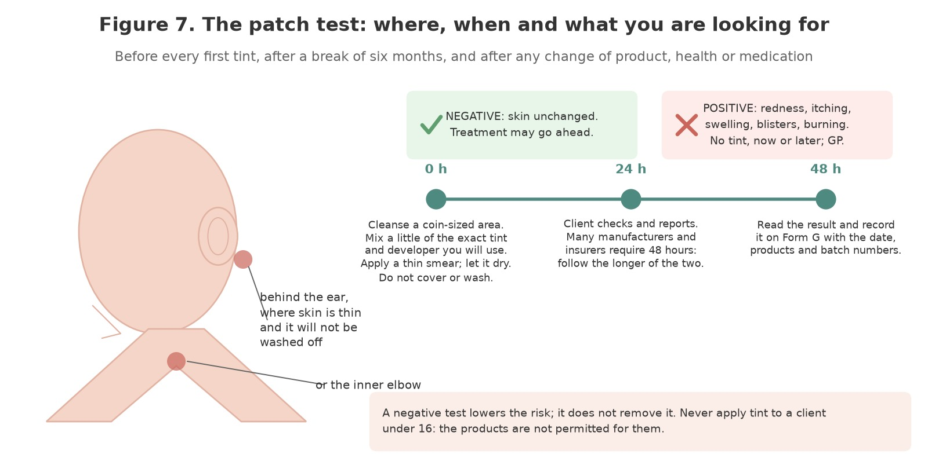
Figure 7. The patch test: behind the ear or in the inner elbow, the exact tint and developer, read at 48 hours and recorded on Form G. A negative result lowers the risk; a positive result (redness, itching, swelling, blistering) means no tint, now or later.
Original illustration © The Looking Glass Beauty School, 2026.
A NEGATIVE PATCH TEST IS NOT A GUARANTEE — Sensitisation can develop at any time, including in a client who has been tinted for years. The test lowers the risk and shows you took reasonable care; it does not remove the risk. Watch every client during development and ask how the skin feels.

Treatment planning
A treatment plan converts consultation findings into a safe, individual service. It should be specific enough that another competent professional could pick up the record and repeat the service.
Planning area | What to decide and record
Client goal | Which treatments; how dark; natural or defined; the shape wanted and the occasion
Hair and skin | Natural lash and brow colour and density; grey or vellus hair; skin type and sensitivity; moles; asymmetry; previous shaping
Patch test | Date, products, batches, site, result and who read it; whether a new test is needed
Products | Tint shade(s), developer, ratio and development time for the lashes and separately for the brows; wax type; pre- and after-wax products
Shape | The three mapped points for each brow, the arch style chosen, what will be removed and what will be left to grow
Adaptation | Tweeze instead of wax; shorter development; lighter shade; one eye only; cool compress; a chaperone or parent present
Risk and consent | Benefits, limitations, allergy information, aftercare, cost and separate photo consent
Review | Rebooking interval (3 to 4 weeks brows, 4 to 6 lashes), what the client should report, and the outcome at the next visit

Consent is informed and ongoing
- The client must understand what will be done, material risks, alternatives and the right to stop. A signature does not remove the duty of care.
- Check consent again if the plan changes, discomfort occurs or another product is proposed. A client who asks for 'a bit darker' half-way through development has changed the plan: say what that means.
- Do not use coercive wording such as 'I accept all responsibility'. A professional remains responsible for acting competently.
- For case-study photographs, obtain model consent for the educational purpose and specify who will see the images, how long they will be kept and whether the face or identity will be excluded. Brow photographs are identifiable; crop or ask.
- If consent cannot be freely and clearly given, do not treat. A client under 16 cannot consent to a tint at all.

Consultation scenario
LEARNER ACTIVITY — A new client books a brow wax and tint and a lash tint for a wedding on Saturday. It is Thursday. She has never had a patch test with you, mentions that a 'henna tattoo on holiday went a bit blistery years ago', wears contact lenses and is using a prescription retinoid cream for acne. Identify what can be done on Saturday, what cannot and why, the questions you would ask, what you would offer instead, and what goes on the record. Write your answer before discussing it with the group.

Chapter 6 — How tint works: oxidative dyes, developers and sensitisation
Why a tint lasts, why it can sensitise, and why the rules exist

What is in the tube
A professional eyelash and eyebrow tint is an oxidative (permanent) hair colourant formulated and safety-assessed for use near the eye. The cream or gel contains small, colourless dye precursors, chiefly aromatic amines such as para-phenylenediamine (PPD) or toluene-2,5-diamine (PTD) and couplers such as resorcinol and aminophenols, in an alkaline base. The developer is a dilute solution or cream of hydrogen peroxide, commonly about 3% (10 volume), far weaker than the developers used on scalp hair. On their own the precursors are nearly colourless; the colour is made when the two are mixed and the mixture meets the hair.
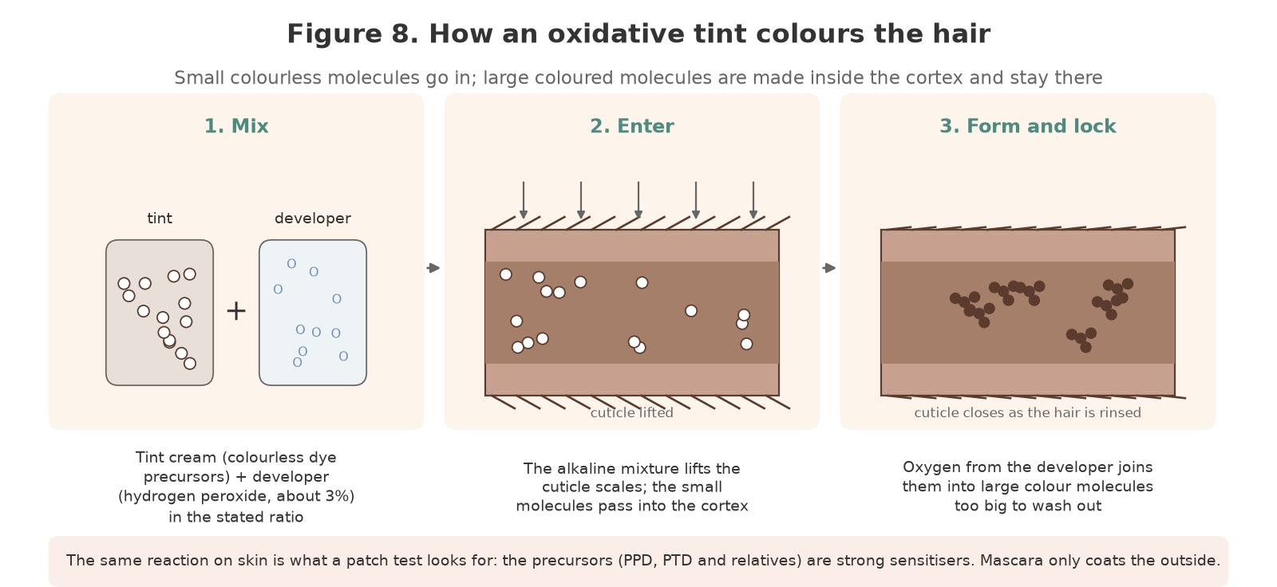
Figure 8. How an oxidative tint colours the hair: the colourless precursors and the developer are mixed, the alkaline mixture lifts the cuticle and the small molecules enter the cortex, and oxygen from the developer joins them into large coloured molecules that are locked inside the hair.
Original illustration © The Looking Glass Beauty School, 2026.

What happens on the hair
- Mixing: tint and developer are combined in the manufacturer's ratio. The reaction starts at once, which is why the mixture is used within minutes and never kept.
- Entry: the alkaline mixture swells the hair and lifts the cuticle scales; the small precursor molecules pass into the cortex.
- Oxidation: oxygen released from the hydrogen peroxide joins the precursors into large coloured molecules. This takes minutes, which is the development time.
- Locking: the new molecules are too large to pass back out through the cuticle, so the colour stays until the hair is shed. The peroxide also lightens the natural melanin slightly, which is why a brow can look a shade warmer after tinting.
- Rinsing and closing: water removes the surface mixture and the cuticle closes as the hair returns to its natural slightly acid state. A damp pad, not a dry rub, protects the cuticle.

What decides the result
Factor | Effect | Professional response
Natural hair colour | Tint adds to the colour that is there; it cannot lighten it. Fair hair takes colour faster and shows it more; dark hair gains depth and definition | Choose the shade for the hair in front of you, not the chart; on fair or grey hair start lighter and build
Shade | Black, blue-black, dark brown, brown, light brown, graphite and chestnut; shades can be mixed in the dish | Lashes: usually black or blue-black; brown for very fair clients. Brows: the natural hair colour or one shade darker; graphite for ash and grey; light brown for blondes
Development time | Longer is darker, up to the point where the reaction is complete | Lashes 5 to 15 minutes by the manufacturer's instruction; brows 1 to 5 minutes, checked at one minute and built in stages
Hair texture | Coarse brow hair takes colour fast; fine lashes slowly; porous or bleached hair grabs colour | Check brows early; give lashes the full time
Developer strength | A stronger peroxide does not give a darker result on lashes; it gives a harsher one and lifts more natural pigment | Only the developer sold for the tint, at the stated ratio. Never hairdressing developer
Cleanliness | Oil, make-up and skin cells block the cuticle | An oil-free cleanse of the lashes and brows is the first step of every tint
The skin | Tint on skin stains the stratum corneum and is shed in days | Barrier cream around the brow and on the lid; tint on skin wiped at once; stains lifted with the manufacturer's remover or a damp pad, never scrubbed

Why tint can sensitise
The dye precursors, PPD above all, are among the strongest skin sensitisers in everyday use. Sensitisation is a learned response of the immune system: a first exposure, or many, teaches the body to recognise the molecule, and a later exposure produces an allergic contact dermatitis, typically 24 to 72 hours later, with itching, redness, swelling, blistering and weeping of the lids and surrounding skin. Rarely the reaction is immediate, with hives, swelling and, at the extreme, anaphylaxis. Once sensitised, a person reacts to that family of dyes for life, which is why a client who has reacted to hair dye or to a black henna temporary tattoo (which contains PPD at high concentration) is never tinted and never patch tested.
The professional is at greater risk than the client, because the professional is exposed every working day. Gloves for mixing, applying and removing, no tint on your own skin, the dish and applicators binned or cleaned at once and the room ventilated are not formalities; they are what keeps you in the job.

The legal position of the products
Eyelash and eyebrow tints are cosmetic products under the UK Cosmetics Regulation (the retained Regulation (EC) No 1223/2009), which lists in its Annex III the oxidative dye substances permitted for use on the eyelashes and the conditions attached: professional use only, maximum concentrations after mixing, and mandatory label warnings. Those warnings include that the product can cause severe allergic reactions, that a skin sensitivity test should be carried out before use, that it must not be used on a person who has reacted to hair dye or has a tattoo including a temporary black henna tattoo, that it is not intended for use on persons under the age of 16, and that the eyes must be rinsed immediately if the product comes into contact with them. A scalp hair dye, however mild its name, is not assessed for the eye area and must never be used there.
NEVER MIX AND HOPE — A tint, its developer, the ratio and the time are one tested system. Another brand's developer, a hairdressing peroxide, a tint 'warmed up' with a drop of something, or a mixture kept in the dish for the next client is an experiment on a client's eyes. If the instructions are not in front of you, do not mix.

Chapter 7 — Brow design: mapping, proportion and shape
What the finished brow must look like before you can produce it
A brow service succeeds or fails on three things that are decided before any hair is removed: where the brow starts, where it peaks and where it ends. Everything else, the thickness, the arch style and the colour, is adjusted within those three points. The points are not a fashion; they are the proportions of the client's own face, and they are found with a straight edge, a pencil and a relaxed client looking straight ahead.

Mapping the brow
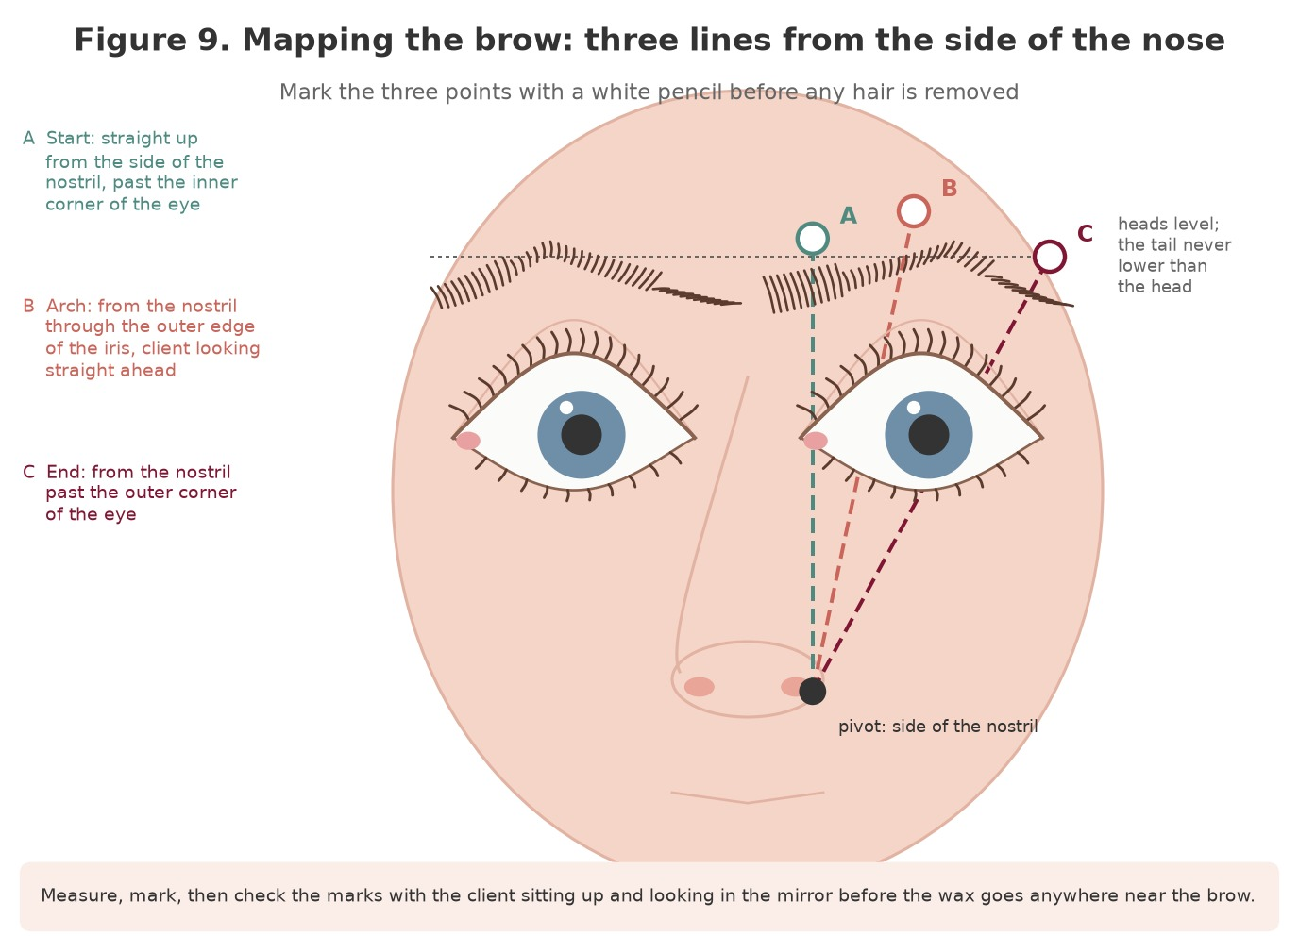
Figure 9. Mapping the brow: three lines from the side of the nostril. A: straight up past the inner corner of the eye to find the start. B: through the outer edge of the iris, client looking straight ahead, to find the arch. C: past the outer corner of the eye to find the end. The heads sit level and the tail never drops below the head.
Original illustration © The Looking Glass Beauty School, 2026.
- Seat or recline the client with the face relaxed and ask them to look straight ahead. Brush the brow hairs up and then into their natural direction.
- Start (A): hold a clean orange stick or brow pencil vertically from the side of the nostril past the inner corner of the eye. Where it crosses the brow is where the brow should begin. Mark it with a white pencil.
- Arch (B): pivot the stick from the same point on the nostril through the outer edge of the iris. Where it crosses the brow is the highest point of the arch. Mark it.
- End (C): pivot the stick from the nostril past the outer corner of the eye. Where it crosses is where the brow should end. Mark it.
- Repeat on the other brow and compare. The two heads should sit level with each other on a horizontal line, and each tail should finish level with or slightly above its head; a tail that drops below the head pulls the whole face down.
- Join the marks lightly with the white pencil along the lower edge of the shape you intend to leave, so that both you and the client can see what will be removed.
- Sit the client up and hand them the mirror. Agree the shape before the wax is warmed, and change the marks if the client wants; this is the last moment that costs nothing.
MEASURE EVERY TIME — The brows the client walks in with have been shaped by someone, usually themselves, usually for years, usually with one side higher than the other. Mapping shows you what their face asks for rather than what their habit has made. Then you decide together how far toward the mapped shape to go today, and how much to leave to grow.

The five basic shapes
Every brow is a variation of five basic shapes, and the natural brow usually tells you which one it wants to be. The shape is refined, never invented: a flat brow cannot be given a high arch with wax, and a client who asks for one needs a conversation, not a treatment. The face shape is a guide to what flatters, not a rule.
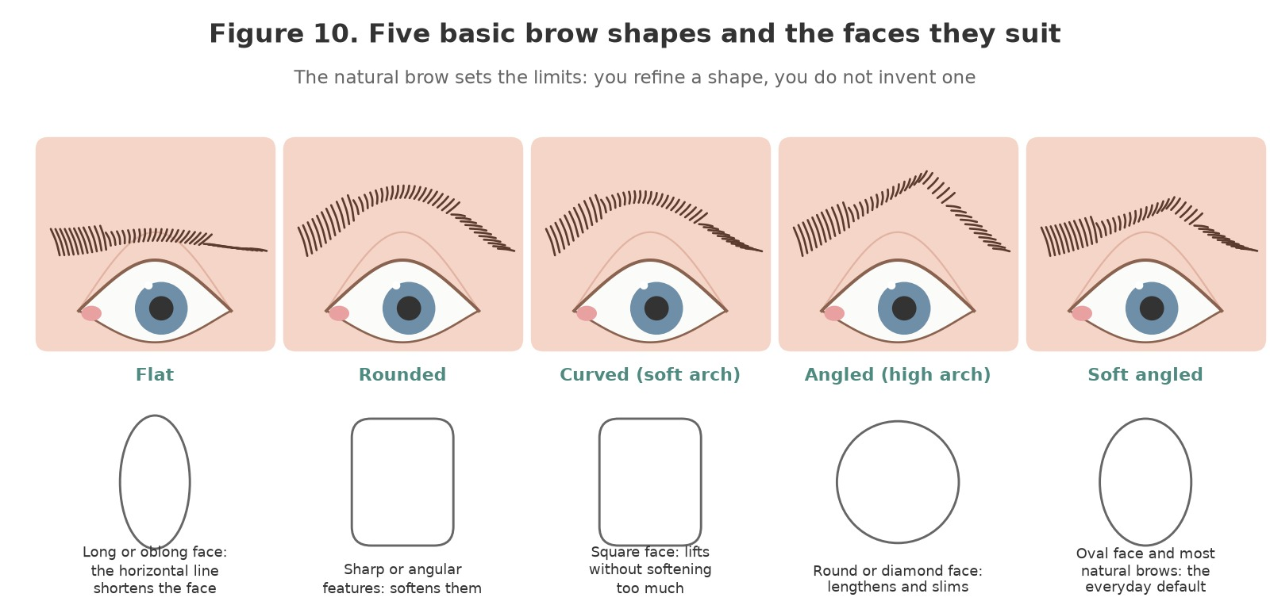
Figure 10. The five basic brow shapes with the face shapes they tend to suit: flat for a long face, rounded to soften angular features, curved for a square face, angled to slim a round or diamond face, and soft angled as the everyday default for an oval face and most natural brows.
Original illustration © The Looking Glass Beauty School, 2026.
Shape | Note for a brow service
Flat (straight) | Little or no arch. Suits a long or oblong face, which it visually shortens. Keep the tail level; any lift at the arch changes the shape entirely.
Rounded | A gentle even curve with no peak. Softens sharp, angular features. Remove hair evenly along the whole lower edge; a point creeps in if you take more from under the arch.
Curved (soft arch) | A clear but soft arch set toward the outer third. Suits a square face: lifts without hardening. The most forgiving shape to maintain.
Angled (high arch) | A defined peak at the mapped arch point and a straighter tail. Lengthens and slims a round or diamond face and reads as youthful. Easy to over-do; the peak is where the hair already rises, not higher.
Soft angled | The angled shape with a lower, softer peak. Suits an oval face and most natural brows; the everyday default and the shape most clients mean by 'natural but tidy'.

What limits the shape
Factor | Effect | Professional response
The natural brow | Hair grows where the follicles are. Gaps, a low tail or a sparse head cannot be waxed into existence | Tint to fill visually; shape what is there; suggest growing in where more hair is needed and leave it alone
Years of self-shaping | Habit has set a shape the client's eye is used to, often too thin or too short | Map, show the difference in the mirror, agree a step toward the mapped shape per visit
Age | Coarser, longer, straighter and greyer hairs; a lower brow as the skin loosens | Trim first, then shape; a slightly higher lower line lifts the eye; graphite or light brown tint for grey
Fashion | Clients bring photographs of brows on a different face | Translate the request into what their face can do; the photograph is a style, not a template
Asymmetry | No face is symmetrical; one brow is usually higher and one arch further out | Map each brow to its own eye, then balance by eye; never try to make a perfect mirror image

Chapter 8 — Kit, equipment, products and storage
Select the right item, use it correctly and keep it clean

The treatment couch and the room
Item | Purpose and safe use
Couch or reclining chair with a head rest | Client semi-reclined for tinting (eyes closed, head still) and reclined or upright for mapping. Covered with a fresh disposable sheet or couch roll for each client; wipeable.
Adjustable stool | The professional sits at the client's head for tinting and to the side for shaping, with the back supported and the forearms resting; see Chapter 9.
Trolley | Everything within reach without stretching over the client's face; wipeable; a lipped top shelf so the wax heater cannot be knocked off.
Lighting | Bright, even, daylight-balanced light on the face; a magnifying lamp for mapping and tweezing. Never a light the client has to stare into.
Hand mirror | For the consultation, after mapping and at the end. The client approves the shape sitting up, not lying down.
Foot-operated bin with a liner | Beside the trolley. Tint pads, spatulas, strips and gloves go straight in; the liner is sealed and changed daily or when full.
Hand-washing facilities and alcohol hand rub | Soap and water before gloves and after; rub between steps when hands are visibly clean.
Sterile saline eye-wash pods and an eye bath | Within arm's reach of the couch before any tint is mixed. Checked in date; a used pod is binned.
First-aid kit and accident book | Stocked, in date and accessible; eye wash counted as part of it.

Tinting kit
Item | Purpose and safe use
Professional eyelash and eyebrow tints | Black, blue-black, dark brown, brown, light brown, graphite and chestnut cover most clients. Tubes closed tightly, stored upright, cool and out of light; batch numbers recorded; discarded at the expiry date or when the product has changed colour or texture.
The matching developer | The manufacturer's own, commonly about 3% hydrogen peroxide, cream or liquid. Never a hairdressing developer. Closed, cool, dark, in date.
Tint dish and measuring aid | Glass or non-porous plastic, cleaned and disinfected after each client; the manufacturer's ratio measured, not guessed.
Disposable applicators | Micro-brushes or fine disposable tint brushes, one set per client, binned after use. A reusable brush is cleaned, disinfected and dried between clients.
Eye pads | Shaped lint-free under-eye pads or shaped damp cotton, one pair per client, placed under the lower lashes. Shaped so they sit flat and do not touch the eye.
Barrier cream | A bland petroleum-based or manufacturer's barrier applied with a disposable applicator to the lid above the lashes, the skin under the pads and around the brow shape; never on the hair.
Oil-free eye make-up remover and cleanser | Removes oil, make-up and debris so the tint takes evenly and the barrier adheres. Oil-based removers leave a film that blocks the tint.
Cotton pads, cotton buds and lint-free wipes | Damp pads for removal; buds for correcting tint on the skin before it sets; dry pads to lift the bulk of the product.
Disposable mascara wands | To comb tint through the brow and separate lashes; one per client.
Tint stain remover | The manufacturer's product for skin staining, used sparingly and never near the eye itself.
Nitrile gloves | Worn for mixing, applying and removing tint; changed between clients and if torn. Latex avoided because of latex allergy.
Timer | Development is timed, not guessed. A visible timer the client can hear.

Waxing and shaping kit
Wax | How it works | On the brow
Hot wax (peelable, stripless, film wax) | Applied warm as a thick layer, sets as it cools, shrink-wraps the hair and is lifted off by its own edge without a strip. Grips short, fine hair; adheres less to the skin | The preferred wax for the eye area: precise, gentle on thin skin, picks up short regrowth. Applied at the manufacturer's working temperature, tested every time; slower than strip wax.
Warm wax (strip wax, soft wax) | Applied thinly at a lower temperature and removed with a paper or fabric strip. Fast; adheres to skin as well as hair | Used for the lines under and between the brows by many professionals. Thin, precise application; small strips cut to size; never a second pass on the same skin.
Pre-wax lotion or cleanser | Removes oil and residue and may include an antiseptic | On the brow area before wax; allowed to dry.
Pre-wax oil or powder | A fine barrier that helps hot wax release from the skin (oil) or keeps the skin dry for strip wax (powder) | Follow the wax manufacturer; one or the other, sparingly.
After-wax lotion or oil | Dissolves wax residue and soothes | Applied with a clean pad at the end; the client's skin is never left tacky.
Item | Purpose and safe use
Wax heater with a thermostat and a lid | On a stable, lipped surface away from the client's head and from water; the lid on between applications; the thermostat at the wax maker's setting, confirmed by the test on your wrist. PAT tested; cable, plug and casing checked before each day; cleaned of drips while warm with the heater's own cleaner.
Wooden spatulas, small and large | One dip per spatula, every time. The spatula that has touched skin never goes back in the pot. Small spatulas for the brow lines; a larger one to load.
Wax strips | Paper or fabric, cut to the size of the area; folded edge for a clean grip.
Slanted tweezers | Stainless steel, clean and disinfected between clients, or sterilised where your policy requires; a sharp accurate tip. Replace when they slip.
Brow scissors | Small, straight or curved, stainless steel; cleaned and disinfected between clients.
Spoolie brushes | Disposable, one per client, to brush the brow up and into shape for trimming and to check the result.
White brow pencil and sharpener | To mark the mapped points and the lower line. Sharpened (and the blade cleaned) between clients so a fresh surface touches each face.
Orange stick or clean straight edge | For mapping. Disposable, or disinfected.
Headband and towel | To keep the client's hair out of the wax and tint.
Cool compress or cool gel pads | For erythema and swelling after waxing or tinting.
LIGHT, HEAT AND AIR SPOIL TINT — A tube left open, a developer left in a warm room or a tint used past its date gives a weak, uneven, unpredictable result and a mixture whose chemistry is no longer what the safety assessment covered. Close everything, store everything cool and dark, and write the opening date on the tube.

Storage, COSHH and disposal
- Keep the Safety Data Sheet for every tint, developer, wax, pre- and after-wax product, cleanser and disinfectant in the salon's COSHH file, and read the first-aid section of the tint and developer sheets before you ever need them.
- Store tints and developers in their original containers, closed, upright, cool and out of light, away from food and from the wax heater. Developer is an oxidiser: keep it away from heat and from anything flammable.
- Never decant developer into an unlabelled container. Never keep a mixed tint.
- Wax heaters are left to cool before cleaning; spilt wax is removed with the maker's cleaner, not a knife or a solvent that could ignite.
- Used tint pads, applicators, gloves, spatulas and strips are general waste in a sealed liner unless contaminated with blood, when the salon's offensive or clinical waste route applies. Wax waste is never poured down a drain.
- Faulty electrical equipment is unplugged, labelled and removed from use; electrical waste goes through the WEEE route.

Chapter 9 — Health, safety, hygiene and ergonomics
Preventing exposure, cross-infection and avoidable injury

Risk assessment and hierarchy of controls
The safest approach removes or reduces a hazard before relying on personal protective equipment. A salon COSHH and risk assessment for lash and brow services should consider the products (tint, developer, wax, cleansers, disinfectants), the tasks, the routes of exposure, the frequency and quantity, ventilation, the people at risk (the professional most of all) and the emergency action for tint in the eye and for an allergic reaction.
Control level | Lash and brow example
Eliminate | Do not use scalp hair dye near the eye; do not tint a client with a history of dye or henna reaction; do not wax skin on a retinoid.
Substitute | Hot wax in place of strip wax on thin or sensitive skin; a lighter tint shade built in stages in place of a long development.
Engineering control | General ventilation and fresh air for tint and developer vapour; a thermostatic wax heater with a lid; a lipped trolley; good lighting.
Administrative control | Training, the consultation and patch-test system, written procedures, timers, closed containers, cleaning schedules, incident recording and review.
PPE | Nitrile gloves for every tint and wax service, a clean apron, and eye protection for the client in the form of pads and closed eyes. PPE is the last line, not the only control.

Routes of exposure
Route | Examples | Control
Skin | Tint and developer on the professional's hands; wax residue; pre-wax products; disinfectant | Gloves changed between clients; no tint on your own skin; hand care; the SDS first-aid steps
Eyes | Tint, developer or cleanser in the client's eye; splash to the professional | Closed eyes, pads and barrier; care with damp pads; saline at the couch; irrigate and refer
Inhalation | Ammonia or amine vapour from freshly mixed tint; developer vapour | Ventilation; mix only what is needed; dishes covered or binned; no tinting in an unventilated cupboard
Ingestion | Eating or drinking at the trolley; contaminated hands | No food or drink in the treatment area; wash hands before breaks
Heat and injury | Hot wax on skin; a dropped heater; scissors and tweezers near the eye | Temperature test; lidded heater on a lipped trolley; tools always pointing away from the eye; the client still

Cleaning, disinfection, sanitation and sterilisation
These terms are not interchangeable. Cleaning physically removes dirt and organic matter and must occur before effective disinfection or sterilisation. Sanitation reduces contamination to an acceptable routine level. Disinfection inactivates many disease-causing microorganisms but may not destroy bacterial spores. Sterilisation is a validated process intended to destroy all viable microorganisms, including spores. For lash and brow work the risk is the eye: a tool or hand that carries conjunctivitis, herpes or a staphylococcal infection from one client to the next does real harm.
Item/method | Correct approach
Hands and skin | Wash with liquid soap and water at the start and end of work and whenever visibly soiled; dry thoroughly. Alcohol hand rub on visibly clean hands between steps. Gloves are not a substitute for washing.
Work surface, trolley and heater exterior | Clean visible soil, then apply a compatible disinfectant for its stated contact time. Never spray liquid into the heater.
Tweezers and scissors | After every client: clean with detergent and a brush, rinse, dry, inspect, then disinfect by immersion in a compatible product for the full contact time, or autoclave where the salon has one. Store dry and covered.
Tint dish and reusable brush | Clean, disinfect, rinse, dry after every client; a reusable brush is discarded when the bristles splay.
Spatulas, applicators, pads, wands, strips, gloves | Single use. One dip per spatula. Binned at once; never set down on the trolley for reuse.
Headband and towel | Laundered at 60°C or above between clients, or disposable.
Couch covering | Changed between every client; the couch wiped with disinfectant daily and after any contamination.
Autoclave | Steam steriliser used only for compatible instruments with validated cycles, packaging, records and maintenance. It is the recognised salon sterilisation method where one is required.
UV cabinet | Storage aid for already clean instruments. It must not be described as a steriliser.
Glass-bead unit, hot-air oven, boiling water | Not accepted as validated salon sterilisation by current local-authority guidance.
Chemical immersion | Usually disinfection in salon use; follow the label, the contact time and the COSHH assessment, and change the solution as instructed.

Standard between-client sequence
- Remove used disposables and place them directly into the lined bin; seal and change the liner if blood is present.
- Move tweezers, scissors and the tint dish to a closed 'used' container; keep them separate from clean tools.
- Clean and disinfect the trolley, the heater exterior, the mirror handle and the couch using the correct contact time; replace the couch covering.
- Perform the full tool-cleaning and disinfection process. Dry, inspect and store protected.
- Wash and dry hands, set out only the clean items needed for the next client and check the saline pods and timer are in place.
- Record completed scheduled cleaning and any contamination incident on Form F.

Blood or skin-break procedure
- Stop the service and move products and tools away from the area.
- Wearing gloves, apply gentle pressure with clean disposable gauze or cotton until the spotting stops.
- Do not apply wax, tint or pre-wax products over broken skin; continue elsewhere only if the break is isolated and covered.
- Dispose of contaminated single-use materials in the route identified by the local waste assessment. Quarantine reusable tools for validated processing.
- Clean and disinfect any contaminated surface using the salon's blood-spill procedure.
- Wash hands after glove removal, record the event on the treatment record and give first-aid and aftercare advice.

Ventilation and vapour
A freshly mixed tint releases a sharp alkaline smell and a small amount of amine and peroxide vapour, and a client lying under it breathes it for ten minutes with the eyes closed. Work in a room with fresh air moving through it, mix only what you need, and bin or cover the dish as soon as the application is complete. Do not rely on smell to judge safety: sensitivity varies, and the client who is most affected is often the one who says nothing.

Ergonomics and prevention of backache and RSI
Area | Good practice
Position | Sit at the client's head for tinting and at the side for shaping. Raise the couch so the client's face is at your elbow height; never stoop to it.
Chair and feet | An adjustable stool with back support; feet flat; hips back; shoulders down.
Arms and hands | Rest the forearm or little finger on the client's forehead or the head rest to steady the applicator and tweezers; a light grip; the wrist neutral.
Neck and vision | Bring the light to the work and the work to your eyes with the couch height and a magnifying lamp, not by bending the neck.
Work pattern | Development time is a rest: stand, stretch and reset between clients. Alternate tinting and shaping clients where the diary allows.
Warning signs | Persistent pain, tingling, numbness, weakness or night symptoms require workload review and appropriate medical or occupational-health advice.
30-SECOND POSTURE RESET — Couch up; stool in; feet flat; hips back; shoulders down; forearm resting; light on the face; tools pointing away from the eye. Reset between every client.

Chapter 10 — UK legislation, insurance, data and advertising
How the rules connect to everyday salon decisions
Legislation changes and local requirements differ. The following summary explains relevance to lash and brow work in Great Britain as at November 2026; it is educational guidance, not legal advice. Businesses must check current official sources, insurer terms and their own local authority before delivery and at each document review.

Core legislation and guidance
Law or requirement | Relevance to a lash and brow professional
Health and Safety at Work etc. Act 1974 | Creates general duties to protect employees and others, including clients, so far as reasonably practicable: safe products, safe equipment, safe systems of work, information and training.
Management of Health and Safety at Work Regulations 1999 | Requires suitable and sufficient risk assessments, arrangements to act on them, competent people and training. The consultation and patch-test system is a control measure under this duty.
Control of Substances Hazardous to Health Regulations 2002 (COSHH) | Tints, developers (an oxidiser and an irritant), waxes, pre-wax products and disinfectants are substances hazardous to health. Assess them, control exposure (gloves, ventilation, closed containers), keep the SDS, provide information and training, and review.
Personal Protective Equipment at Work Regulations 1992, as amended in 2022 | Where risk remains after other controls, employers must provide suitable PPE free of charge, maintain it and train in its use; since 2022 the duty extends to limb (b) workers. Nitrile gloves for every tint and wax service.
Health and Safety (First-Aid) Regulations 1981 | Adequate first-aid provision for the work: a stocked kit, sterile eye wash where the eyes are at risk (they are), an appointed person or first aider, and records.
Reporting of Injuries, Diseases and Dangerous Occurrences Regulations 2013 (RIDDOR) | Specified work-related injuries, dangerous occurrences and diagnosed occupational diseases, including occupational dermatitis and asthma from workplace sensitisers, must be reported. A client's reaction is recorded and reported to the insurer; a professional's diagnosed dermatitis may be reportable.
Electricity at Work Regulations 1989 and the Provision and Use of Work Equipment Regulations 1998 (PUWER) | Wax heaters, magnifying lamps and any other electrical equipment must be suitable, maintained, inspected and used only by trained people. User checks before each day; inspection and testing at intervals based on risk; faulty equipment withdrawn.
Regulatory Reform (Fire Safety) Order 2005 | A wax heater is a heat source: a fire risk assessment, no flammable products stored by it, the heater off and cooling at the end of the day, extinguishers and exits maintained.
Workplace (Health, Safety and Welfare) Regulations 1992 | Ventilation, lighting, temperature, cleanliness, hand-washing facilities and seating suitable for the work.
Environmental Protection Act 1990 (duty of care for waste) | Salon waste, including wax, strips and tint pads, is disposed of through a licensed route with transfer notes; blood-contaminated waste through the offensive or clinical route your local authority requires; nothing down the drain.
Cosmetic Products Enforcement Regulations 2013 and the retained Cosmetics Regulation (EC) No 1223/2009 | Eyelash and eyebrow tints supplied in GB must meet safety, responsible-person, labelling and ingredient rules. Annex III permits specific oxidative dyes for professional use on the lashes with mandatory warnings: allergy warning, sensitivity test, not for persons under 16, not for anyone who has reacted to hair dye or black henna, rinse eyes immediately. Using a product outside its labelled use (scalp dye on lashes) breaches the professional's duty of care and may void insurance.
Consumer Rights Act 2015 | Services must be performed with reasonable care and skill, information relied on by the client is binding, and the price and time stated must be honoured. A client is entitled to a repeat performance or a price reduction if the service falls short.
Digital Markets, Competition and Consumers Act 2024 (unfair commercial practices) | From April 2025 this replaced the Consumer Protection from Unfair Trading Regulations 2008. Misleading claims, omitted material information (such as the need for a patch test before a tint) and fake reviews are prohibited.
Data Protection Act 2018 and UK GDPR | Client contact details, consultation records, health information, patch-test records and photographs are personal data; health information is special-category data. See the data section below.
Equality Act 2010 | Service providers and educators must not unlawfully discriminate and must make reasonable adjustments. Age is a protected characteristic, but refusing to tint a client under 16 is required by the product's conditions of use and is lawful.
Local Government (Miscellaneous Provisions) Act 1982; London Local Authorities Act 1991; Civic Government (Scotland) Act 1982; Public Health (Wales) Act 2017 | Licensing and registration of premises and treatments is local. Eyelash and eyebrow treatments are not generally licensable outside London, but some London boroughs class beauty treatments as special treatments needing a licence, and Scotland and Wales have their own schemes. Always confirm with your own local authority before trading.
Employers' Liability (Compulsory Insurance) Act 1969 | Most businesses employing staff must hold employers' liability insurance and display the certificate.
Whatever the nation, always confirm licensing and registration requirements with your own local authority and your insurer before trading.

Public liability, treatment risk and product liability
Public liability insurance is not one of the Acts listed above, but it is an essential business control and may be required by venues, landlords, local authorities, training providers or contracts. A lash and brow professional should confirm that cover includes eyelash tinting, eyebrow tinting and eyebrow waxing by name, the products used, teaching activities, students and models, premises and working arrangements. Treatment or professional liability and product liability may be included or separate. Policy conditions almost always set a patch-test rule (how long before, how often, how recorded), a minimum client age, and a requirement for consultation records; a claim is defended on those records.
- Never assume the salon policy covers a self-employed professional or educator; obtain written confirmation.
- Notify the insurer promptly about an adverse reaction, injury, complaint or potential claim according to the policy. Do not admit liability or alter records.
- Keep factual, contemporaneous consultation, patch-test and treatment records for the period agreed with the insurer and documented in the business retention schedule, commonly seven years and longer for clients under 18.
- If employing anyone, confirm employers' liability and health-and-safety duties in addition to public and treatment cover.

Data protection in consultation and case studies
Principle | Salon action
Transparency | Give a privacy notice explaining controller identity, purposes, lawful basis and condition, recipients, retention, security and client rights.
Data minimisation | Ask only what is necessary for safe treatment. A full medical history is unnecessary; the questions in Form A are the ones that matter.
Health data | Document the relevant Article 6 lawful basis and Article 9 condition. Explicit consent may be available where genuinely appropriate, but treatment consent and data consent are different things.
Security | Lock paper files; use access-controlled, backed-up systems; avoid client details and brow photographs in personal messaging and photo galleries; restrict staff access.
Accuracy | Confirm changes at every appointment and record what the client said without turning observations into a diagnosis.
Retention | Use a written schedule based on purpose, insurer and legal advice and limitation periods; review and securely delete or anonymise when no longer needed.
Photographs | Use separate optional consent. Brow and eye photographs are identifiable; state educational, assessment and marketing uses individually and never post a case-study image without the consent that covers that use.
Breach response | Contain, assess, document and report qualifying personal-data breaches to the ICO within required timescales where applicable; inform affected people where required.

Advertising Standards Authority (ASA) and CAP guidance
Advertising includes websites, booking pages, social media, paid posts, influencer content, leaflets and claims made in before-and-after images. The ASA and CAP position is that beauty marketers must hold evidence for objective efficacy claims and must not exaggerate effects or omit material information such as the need for a patch test.
Avoid | Use instead
'Permanent' or 'semi-permanent mascara' | 'Lash tint: defined, waterproof colour that lasts until the lashes naturally shed, usually four to six weeks.'
'Makes lashes grow longer and thicker' | 'Darkens the lashes you have, including the fine tips, so they look longer.' Tint does not affect growth.
'Hypoallergenic', 'allergy-free', 'no patch test needed' | Describe the product accurately, state that a patch test at least 48 hours before is required, and acknowledge that reactions are possible.
'Pain-free brow wax' | 'Quick and gentle, with hot wax designed for the eye area; most clients feel a brief sting.'
'HD brows' or any other trade mark you are not licensed to use | 'Brow wax, tint and shape' or 'brow design'.
'Suitable for everyone' or 'from age 12' | State the minimum age for tinting (16, with parental consent to 18 where the insurer requires) and that a consultation decides suitability.
'Qualified lash and brow technician' based only on this CPD activity | 'Trained in lash and brow tinting and shaping (CPD)', with the underlying qualification described accurately.
Heavily retouched before-and-after images or inconsistent lighting | Comparable lighting and angle, the face relaxed, originals retained, consent obtained and editing disclosed.
ASA RESOURCE — Learners should review the current ASA/CAP 'Beauty and Cosmetics: General' guidance before advertising: https://www.asa.org.uk/advice-online/beauty-and-cosmetics-general.html

Electrical and wax heater checklist
- ☐ The heater is a professional unit with a thermostat and a lid, from a reputable supplier, with instructions in English.
- ☐ Plug, cable, casing and thermostat dial show no damage, heat marks, wax build-up on the element or exposed parts.
- ☐ The heater stands on a stable, lipped, heat-resistant surface away from the client's head, water and anything flammable.
- ☐ The wax is at the maker's working temperature and has been tested on your inner wrist before the first client.
- ☐ User checks, inspection and test intervals and maintenance are based on risk and recorded; an annual sticker is not treated as the only control.
- ☐ Faulty equipment is unplugged, labelled and removed from use pending competent repair or WEEE disposal.

Chapter 11 — Preparing the client and the treatment area
Everything that happens before the first product touches the client

Before the client arrives
- Check the consultation record and Form G: a negative patch test with the exact products within six months, or a patch test booked and read. No record means no tint today.
- Switch the wax heater on in good time, lid on, thermostat at the maker's setting. Check the cable and casing.
- Cover the couch, set the head rest, and lay the trolley: tints, developer, dish, applicators, pads, barrier cream, cleanser, cotton, wands, timer, pencil, orange stick, spatulas, strips, tweezers and scissors (clean, from the closed container), pre- and after-wax products, gloves, a cool compress, and the saline pods within arm's reach.
- Wash your hands. Put the mirror where the client can reach it.

Settling and preparing the client
- Welcome the client, confirm the plan from the record, and ask the two questions that change everything: 'Has anything changed in your health, medication or skin since last time?' and 'Any reaction to anything since the patch test?'
- Look at the eyes, lids and brow skin in good light (Chapter 4). Check the patch-test site if you can see it. Record.
- Contact lenses out, into the client's own case. Jewellery that could catch the wax or the applicator off. Headband on; hair back; a towel over the clothing.
- Recline the client for tinting (semi-reclined, head level, chin slightly up so the lashes rest on the pads) or sit them up for mapping. Explain each step before you do it: a client who knows what is coming keeps still.
- Wash hands again and put on gloves.
- Cleanse the lashes and brows with an oil-free remover on a damp pad, eyes closed, wiping away from the eye, until the pad comes away clean. Dry gently. Brush the brows with a disposable wand.
- Agree the stop signal: a raised hand, since the client cannot speak easily with the eyes closed and will not be opening them.

Protecting the eyes and skin for a tint
- Barrier cream with a disposable applicator: a thin line along the upper lid just above the lash line, under the lower lashes on the skin where the pad will sit, and around the brow shape on the skin. Not on the hair, which it would seal against the tint.
- Place the under-eye pads with the client's eyes closed and looking slightly up under the lids, so that the pad tucks under the lower lashes and rests on the skin, not against the eye. Check that no lower lash is trapped under the pad and that the inner corner is covered.
- Eyes closed and relaxed from now until the last wipe. A squeezed eye pushes tint toward the margin: say 'rest the eyes closed, as if you are asleep', not 'shut your eyes tight'.
- Check the saline pod is open-able and within reach; check the timer. Only then mix.
THE ORDER OF THE DAY — Brows are tinted before they are waxed: tinting after a wax puts an alkaline chemical on skin whose follicles are open, stings, stains and risks sensitising. Lashes are tinted first or at the same time as the brows, and the shaping comes last, when the tint is off and the skin is clean. Tint, tidy, shape.

Chapter 12 — Eyelash tinting
Protect, apply, develop, remove: the eyes closed throughout

Choosing the shade
Most clients want black for the lashes: it reads as definition rather than colour and darkens the fine, pale tips that mascara reaches and the eye does not. Blue-black gives a cooler, denser black on already-dark lashes. Brown, or a brown and black mix, suits a very fair or red-haired client who wants definition without a line of black. Lash tint is one shade, developed for the full time; there is no checking at one minute as there is with brows, because the lashes are under the pads and the eyes are closed.

The procedure
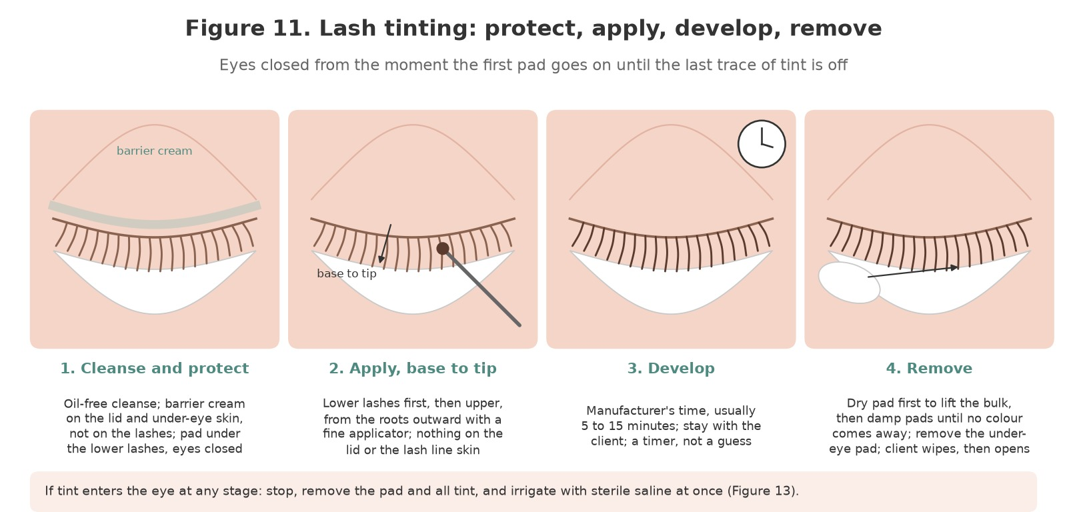
Figure 11. Lash tinting in four stages: cleanse and protect with barrier cream and the under-eye pad; apply from base to tip, lower lashes first, then upper; develop for the manufacturer's time with the client never left alone; remove with a dry pad then damp pads until no colour comes away, the eyes still closed.
Original illustration © The Looking Glass Beauty School, 2026.
- With the client prepared as Chapter 11 describes (cleansed, pads in, barrier on, eyes closed, saline at hand), mix the tint and developer in the manufacturer's ratio in the dish. Use within the time the maker states; the mixture thickens and loses strength.
- Load a fine disposable applicator with a small amount. Starting with the lower lashes, which lie on the pad, coat them from the base to the tip with the applicator moving outward, on both eyes.
- Upper lashes: with the eye closed, stroke the tint from the base of the lashes to the tips, working from the inner corner to the outer, then back over the roots from above with the lid gently supported. Every lash coated; nothing on the lid skin or the margin. A wet cotton bud removes any tint that touches skin at once.
- Check both eyes from the side and from above the client's head: the tips coated, the roots coated, no tint pooling at the inner corner.
- Start the timer for the manufacturer's development time, commonly 5 to 15 minutes, 10 as a usual starting point. Bin the applicator; cover or bin the dish.
- Stay with the client. Ask how the eyes feel at intervals. Watering, stinging or a hand raised: stop and go to the removal steps at once, and to Chapter 16 if tint has reached the eye.
- If the brows are being tinted in the same appointment, apply the brow tint now so that both develop together (Chapter 13), timing each separately.
- Removal: with the eyes still closed, lift the bulk of the tint from the upper lashes with a dry pad, wiping from the roots outward and downward onto the under-eye pad. Then damp pads, one at a time, from the inner corner outward, until a fresh damp pad comes away clean.
- Remove the under-eye pads by sliding them outward and down, away from the eye, taking the lower-lash tint with them. Wipe the lower lashes with a damp pad.
- Wipe the inner corner outward with a fresh damp pad and dry the lid and the corner with a dry pad. Only now ask the client to open the eyes slowly, and hand them a damp pad to blot anything they feel.
- Inspect: even colour root to tip, both eyes matching, no tint on the skin or margin. A fleck on the skin is lifted with a damp bud now, before it sets.
- Remove the barrier cream with a clean pad, apply a cool compress if the lids are pink, and give aftercare (Chapter 17). Record the shade, the development time, the batch numbers and anything unusual.
TINT IN THE EYE — It stings at once and the client will tell you. Do not finish the development, do not reassure and wait: stop, remove the pad and all the tint from that eye with damp pads, tilt the head to that side and irrigate with sterile saline from the inner corner outward for at least ten minutes (Figure 13). Record it. Refer if any symptom persists. Then ask yourself why it happened.

Reading the lashes as you work
What you see | What it means | What to do
Tint beading off the lashes | Oil or make-up left on the hair; barrier cream on the lashes | Remove, re-cleanse with oil-free remover, re-protect and start again
Tint creeping onto the lid skin | Too much on the applicator; the lid not supported; the eye squeezed | Lift it at once with a damp bud; load less; ask for relaxed closed eyes
Eyes watering during development | Vapour, a dry eye, hay fever, or tint reaching the margin | Blot the outer corner with a dry pad without opening the eye; if it continues or the client reports stinging, remove the tint and irrigate
Client raises a hand or says it stings | Tint or developer in the eye | Stop; remove; irrigate; Chapter 16
Tips still pale after removal | Tips not coated, or a fine fair lash that needed the full time | Note it; next time coat the tips first and give the full development; do not re-apply today over a client whose lids are pink
Patchy result | Uneven application or a shortened development | Technique: base to tip on every lash, both directions, the full time

Chapter 13 — Eyebrow tinting
A shade that suits, checked at one minute and built in stages

Choosing the shade
Shade | Natural hair it suits | Note
Light brown | Blonde, fair and strawberry-blonde brows | The commonest choice that is wrong when it is skipped: a blonde given dark brown looks drawn on
Brown (natural brown) | Light to mid brown hair | Adds depth and covers vellus hair without changing the colour
Dark brown | Mid to dark brown hair | Definition for brunettes; one shade darker than the hair is the usual limit
Graphite (grey) | Ash blonde, grey and white brows; cool-toned clients | Avoids the warmth that brown and black bring; ideal for mature clients
Chestnut (red) | Red and auburn hair, or mixed with brown to warm it | Rarely used alone
Black and blue-black | Very dark hair only | On the brows black is a strong choice; most clients who ask for it want dark brown
Shades can be mixed in the dish to match the client, and the mixture recorded so it can be repeated. A tint cannot lighten; if the client wants lighter brows, that is a different service and a different professional. On a first visit go one step lighter than you think and build: a brow can always be tinted darker, and will be in four weeks anyway.

The procedure
- Brows cleansed with oil-free remover and brushed into shape; barrier cream around the shape on the skin, not on the hair; the client reclined with the eyes closed, or sitting up with the eyes closed if the brows alone are being tinted.
- Mix a small quantity of the chosen shade or mix with the developer in the maker's ratio.
- With a fine applicator, apply the tint to the brow hairs against the direction of growth first, to coat the roots and the underside, then brush it through with the growth so every hair is coated. Work from the tail toward the head, because the fine hairs at the tail take longer than the coarse hairs at the head.
- Keep the tint within the mapped shape. Tint on the skin outside the shape is wiped at once with a damp cotton bud; tint on the skin inside the shape will stain for a day or two and show the shape, which many clients like and some do not: ask.
- Comb through with a disposable wand so no hair is missed and no excess sits on the skin.
- Start the timer. Brow hair tints fast: check at one minute by wiping a small section at the tail with a damp pad. If it is not dark enough, re-apply to that section and continue for a further minute or two, checking each time, up to the manufacturer's maximum (commonly 3 to 5 minutes).
- Remove with a damp pad, wiping against the growth and then with it, until the pad comes away clean. Brush the brow up and across to check for missed hairs and for stray tinted vellus hair outside the shape, which the shaping will remove.
- Lift any skin staining with the maker's stain remover on a cotton bud, kept well away from the eye, or with a damp pad; never scrub. Remove the barrier cream.
- Sit the client up with the mirror and agree the depth before you shape. Record the shade or mix, the time and the batch numbers.
CHECK AT ONE MINUTE — The brow is the one place a tint is checked early, because coarse hair takes colour fast and a brow that is too dark cannot be undone today. Thirty seconds too long on a blonde is a fortnight of apologies.

Reading the brows as you work
What you see | What it means | What to do
Colour very dark at one minute | Coarse or porous hair; a shade too dark | Remove at once; next time a lighter shade or mix
Colour not taking at the tail | Fine hair; oil; too little tint | Re-cleanse the tail, re-apply, develop longer at the tail only
Skin staining inside the shape | Normal for a thorough application | Wiped at removal; tell the client it fades within one to three days and shows the shape meanwhile
Skin staining outside the shape | Tint beyond the mapped line | Stain remover on a bud, carefully; keep inside the line next time
Stinging or itching during development | A sensitive client, broken skin, or the beginning of a reaction | Remove at once, cool compress, Chapter 16; no wax today on that skin
A warm or orange cast after a few days | The peroxide has lifted the natural pigment as the tint faded; common on fair hair tinted with warm browns | Graphite or an ash mix next time, and a shorter development

Chapter 14 — Eyebrow shaping: waxing, tweezing and trimming
With the growth on, against the growth off, the skin taut and the eyelid untouched

Before any hair is removed
- Map the brows and agree the shape in the mirror (Chapter 7). Draw the lower line of the shape to be kept with the white pencil; the wax goes below it.
- Check the skin again: no retinoids, isotretinoin, sunburn, peels, injectables or broken skin as Chapter 4 describes; no moles or skin tags in the wax path. Confirm the client has not used an acid or retinol product in the last week.
- Test the wax: a little on a spatula onto your own inner wrist. It should be workable and warm, never hot. Then a small test on the client's skin, at the temple or the outer brow, and ask. Only then the first application.
- Cleanse the brow area with pre-wax lotion and let it dry; apply pre-wax oil or powder as the wax maker directs.
- Gloves on, if they are not already. Hair out of the way under the headband. A fresh spatula in hand.

Waxing the brow
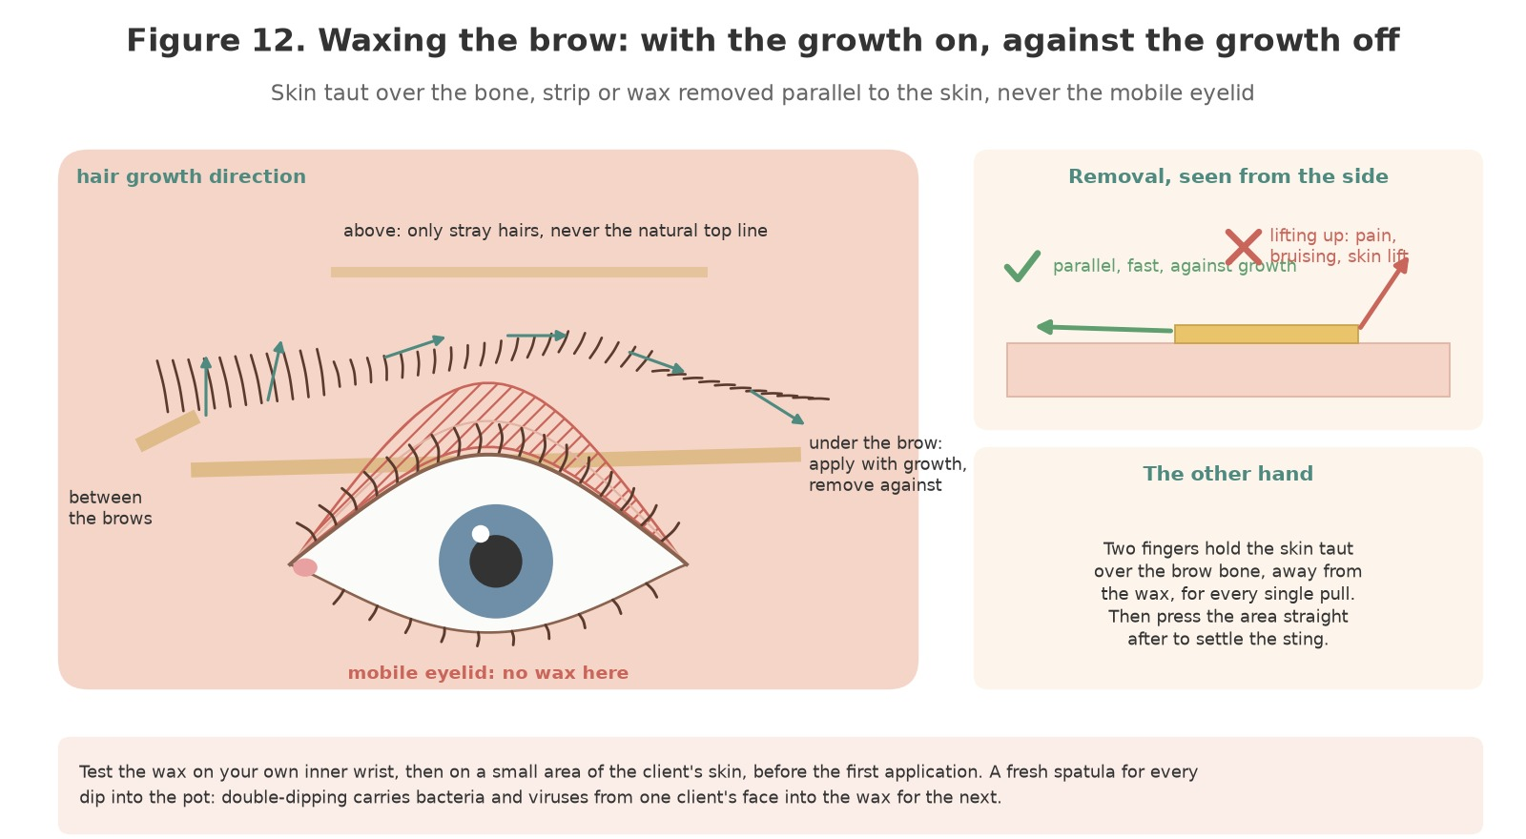
Figure 12. Waxing the brow: the hair grows up at the head, along the arch and down at the tail, so the wax is applied with that growth and removed against it. Skin held taut over the bone, the wax or strip removed parallel to the skin, never upward, and never on the mobile eyelid.
Original illustration © The Looking Glass Beauty School, 2026.
- Under the brow, outer section first: with the skin held taut by two fingers of the other hand placed above and below the area, apply a thin, even layer of wax with the growth, from the arch toward the tail, just below the pencil line. For hot wax leave a slightly thicker edge to lift; for strip wax press a cut strip on with the growth and smooth it twice.
- Hold the skin taut and remove against the growth, fast and parallel to the skin, close to the surface. Never lift upward or outward. Press the area firmly with a clean finger or pad at once; pressure settles the sting.
- Under the brow, inner section: from the head toward the arch, the same way, keeping below the line. The hairs here grow upward, so the wax goes on upward and comes off downward.
- Between the brows: a small application with the growth (upward) between the two mapped start points, removed downward with the skin held taut at the bridge of the nose. Do not take the heads further apart than the map.
- Above the brow: stray hairs only, never the natural top line, which gives the brow its shape and which does not grow back the same. Most professionals tweeze above rather than wax.
- The other brow, matching section for section, so that you compare as you go. A fresh spatula for every dip into the pot, every time.
- Never wax the mobile eyelid, the skin between the crease and the lashes: it is the thinnest skin on the body, it lifts, and the lash line and tear ducts are beneath it. Hair there is tweezed if the client wants it gone.
- One pass per area. A second pass on skin that has just been waxed takes skin. A hair the wax missed is tweezed.
DOUBLE-DIPPING — The spatula that has touched a client's skin carries whatever is on it, including the viruses that cause cold sores and warts and the bacteria behind styes and impetigo, into the pot and onto the next client's face. One spatula, one dip, bin. There is no exception for 'clean-looking' skin.

Tweezing
- With the skin held taut, grip each stray hair close to the skin with slanted tweezers and pull in the direction of growth in one smooth movement. Pulling against the growth breaks the hair below the surface and invites an ingrown hair.
- Work in good light with the magnifier, stepping back after every few hairs to check the balance of the pair; it is easy to over-tweeze one side while concentrating on it.
- Tweeze the fine vellus hair the wax left and the single hairs the map excluded; do not thin the body of the brow unless that is the agreed shape.
- Around a mole or skin tag, tweeze the hairs the client wants gone; never wax, and never pull hair from the mole itself.

Trimming
- Brush the brow hairs straight up with a disposable wand. Hairs that extend above the natural top line are trimmed with brow scissors, following the top line, a little at a time.
- Brush the hairs down and across toward the tail; trim only the tips that fall below the lower line. Over-trimming leaves blunt stubs that stand up and a brow that looks sparse.
- Brush back into shape and check both brows in the mirror with the client sitting up. Trim a hair, not a brow.

Finishing
- Remove every trace of wax with after-wax lotion or oil on a clean pad; the skin is never left tacky.
- Apply a soothing after-wax lotion or a cool compress; erythema and slight swelling are normal and settle within an hour or two.
- Check the shape with the client in the mirror, sitting up, face relaxed. Agree what was left to grow and what to do next time.
- Give aftercare (Chapter 17), rebook for three to four weeks, and record the wax used, the areas treated, the shape and any contra-action.
- Clear the trolley: spatulas, strips, pads and gloves to the bin; tweezers and scissors to the used container; the heater lid on.

Chapter 15 — Results, longevity and troubleshooting
Reading a service that has gone wrong, and setting expectations before it does
Problem | Likely cause | Prevention or fix
Lash tint faded within two weeks | Oil-based cleanser or make-up remover; shortened development; tint beaded off lashes that were not clean | Oil-free cleanse before; the full development; oil-free aftercare advice
Lash tint patchy or tips pale | Tips not coated; uneven application; eyes opened during development | Base to tip in both directions on every lash; eyes closed; the full time
Brow tint too dark | Shade too dark for the hair; development not checked at one minute; coarse or porous hair | Lighter shade or mix; check at one minute; build in stages; on the day, a gentle damp wipe only (never a stripper near the eye) and honesty: it softens within days
Brow tint too light or did not take | Fine or grey hair; oil; too short | Re-cleanse; longer development at the tail; graphite for grey rather than more time with brown
Skin staining around the brow | Tint on skin outside the shape; no barrier | Barrier cream; keep within the line; stain remover on a bud away from the eye; it fades in one to three days
Brow tint turned warm or orange | Peroxide lifted the natural pigment under a warm shade | Cooler shade or graphite mix; shorter development
Erythema and swelling lasting hours after a wax | Sensitive skin; wax too hot; a second pass; skin not held taut | Temperature test; one pass; taut skin; cool compress; hot wax rather than strip wax next time
Skin lifted (a raw, shiny patch) after a wax | Retinoid, isotretinoin, steroid or exfoliant use; a second pass; wax removed upward; sunburn | Chapter 4 questions; one pass; parallel removal. On the day: cool compress, a bland barrier, no make-up, the client told to watch for infection; record
Burn | Wax too hot; thermostat faulty; no test | Temperature test every time. On the day: cool running water for 20 minutes if possible, no ice, a sterile dressing, medical advice; record and report
Blood spots after waxing or tweezing | Normal where coarse hair is removed; more on anticoagulants | Pressure with a clean pad; no products on the spots; aftercare; note it
Bruising | Skin not held taut; wax pulled upward; anticoagulants | Technique; the client warned; cool compress
Hairs broke off instead of coming out | Wax too thin or too cool; strip removed slowly; hair too short | Working temperature; a decisive parallel pull; a hair under 2 mm is left to grow
Ingrown hairs or folliculitis a week later | Broken hairs; tweezing against the growth; the client touching the area or using heavy products | Technique; aftercare: clean hands, no heavy creams for 24 hours, gentle exfoliation after 48 hours
Brows uneven after shaping | Mapped by eye not by measurement; shaped lying down; concentrated on one side | Map every time; check sitting up; alternate sides
Itching, swelling or weeping lids 24 to 72 hours after a tint | Allergic contact dermatitis | Chapter 16: no further tint; GP; record; report to the insurer and the manufacturer. Prevented by the patch test, not cured by it

Setting expectations honestly
- A lash tint lasts four to six weeks and fades gradually as the lashes shed. A brow tint lasts three to four weeks on the hair and one to three days on the skin. Nothing lasts longer because the hair is replaced.
- Tint does not make lashes or brows grow, thicker or longer. It darkens what is there, including the tips the eye could not see, which is why they look longer.
- A brow is shaped toward what the face asks for, usually over two or three visits as the right hairs grow in. The client who wants a different brow on the first visit needs the mapping explained, not a wax.
- The first day after a brow tint is the darkest it will be; the skin stain fades first. Say so before the client sees the mirror.
- Redness after waxing is normal and settles within one to two hours; a few blood spots on coarse hair are normal. Swelling, itching or weeping that appears the next day is not, and the client should call.
- Never promise a number of weeks. Explain what affects it and record what you advised.

Chapter 16 — Contra-actions, adverse reactions and emergencies
Recognise early signs, stop exposure and escalate appropriately

Contra-action or adverse reaction?
A contra-action is an expected or minor unwanted response to a treatment that is carried out correctly: erythema and slight swelling after waxing, watering during a tint, a few blood spots, a day of skin staining. An adverse reaction is a harmful response to a product or process: allergic contact dermatitis, an immediate allergic reaction, a chemical injury to the eye, a burn, a skin lift, an infection. The professional does not diagnose the mechanism; they recognise the signs, stop exposure, give proportionate first aid, record and refer.
Event | Possible signs | Immediate management
Erythema after waxing | Pink or red skin, warmth, mild swelling in the waxed area | Cool compress; soothing after-wax lotion; no make-up for 24 hours; settles within one to two hours
Watering during a tint | Tears from the outer corner, eyes closed | Blot the outer corner with a dry pad without opening the eye; if stinging is reported, treat as tint in the eye
Tint or developer in the eye | Immediate stinging or burning, watering, redness of the white of the eye, the client's hand raised | Stop; remove the pad and every trace of tint from that eye with damp pads; tilt the head to that side; irrigate with sterile saline from the inner corner outward for at least 10 minutes; contact lens out once irrigation has begun; no rubbing. Persistent pain, blurred vision, light sensitivity or redness: NHS 111, an optician or A&E. Record
Tint on the skin or margin | Stinging, a grey stain | Remove at once with a damp bud; cool compress; no stain remover near the eye
Immediate allergic reaction | Within minutes: itching, hives, swelling of the lids or face, wheeze | Remove all product; cool compress; antihistamine advice from a pharmacist for mild symptoms; call 999 for breathing difficulty, throat or tongue swelling, faintness or collapse; do not leave the client alone
Delayed allergic contact dermatitis | 24 to 72 hours later: itching, red, swollen, blistered or weeping lids and surrounding skin, sometimes spreading to the face | Advise cool compresses and a pharmacist or GP (topical steroid and antihistamine are prescribed, not by you); no further tint of that type ever; record; report to the insurer and the manufacturer's responsible person; review the patch-test record
Blood spots | Pin-point bleeding at the follicles after waxing or tweezing | Pressure with a clean pad; no products on the spots until closed; the blood procedure for waste and tools
Skin lift | A raw, shiny or weeping patch where the wax removed the surface skin | Cool compress; a bland barrier; no make-up or products; the client told to keep it clean and watch for infection; record the cause; no wax there until fully healed
Burn | Pain beyond the normal sting, a red or blistered patch, skin peeling | Cool running water for 20 minutes if practicable; no ice, creams or wax remover on the burn; a sterile non-adherent dressing; medical advice; record and report; the heater withdrawn until checked
Bruising | Blue or purple mark appearing after waxing | Cool compress; arnica is the client's choice, not your prescription; record; review technique and ask about anticoagulants
Folliculitis or ingrown hair | Red bumps or pustules at follicles days later | Advise warm compress, clean hands, gentle exfoliation after 48 hours; a pharmacist if spreading or pustular; no wax over it
Suspected infection or spreading redness | Increasing pain, heat, swelling, pus, a red eye or a spreading rash | Do not treat or cover; advise urgent pharmacy, GP or NHS 111 assessment; emergency care if the client is unwell; record
Faintness | Pale, sweating, 'going dizzy' during or after waxing | Lie flat, legs raised, fresh air, time; water when recovered; do not continue until fully well; record
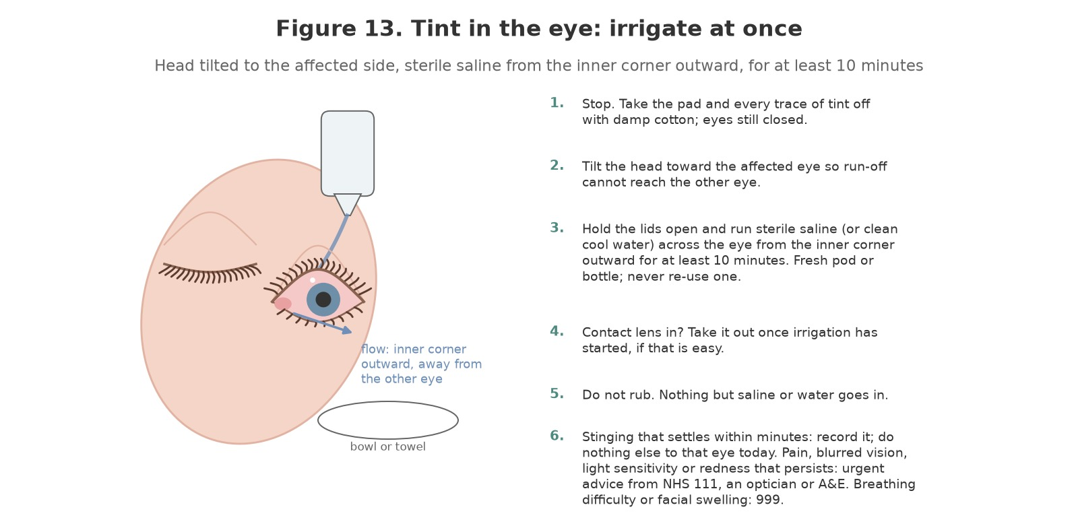
Figure 13. Tint in the eye: stop, remove the tint, tilt the head to the affected side and irrigate with sterile saline from the inner corner outward for at least ten minutes, then refer if any symptom persists.
Original illustration © The Looking Glass Beauty School, 2026.

General adverse-reaction response
- STOP the treatment and prevent further exposure.
- REMOVE the product safely without spreading it; damp pads for tint, after-wax oil for wax; nothing else on the skin unless the SDS directs.
- RINSE or provide first aid according to the exact product SDS and first-aid training: saline irrigation for the eye, cool water for a burn, a cool compress for skin.
- ASSESS urgency. Call 999 for emergency signs; otherwise advise NHS 111, an optician, the GP or a pharmacist as appropriate.
- RECORD factual signs, times, the affected area, product names, shades, batch numbers, development time, wax type and temperature, PPE, action taken, advice given and witnesses on Form E. Photograph only with consent and without delaying care.
- REPORT internally, to the insurer and, for a serious reaction to a cosmetic product, to the manufacturer or responsible person named on the label, who has a legal duty to record it. Preserve the product and records; do not alter notes.
- REVIEW the COSHH assessment, the patch-test record, the products, the technique and the consultation before any further service. Never re-test a client who has reacted.

Sensitisation prevention for professionals
- Gloves for every mix, application and removal of tint, every time, not only when a reaction is suspected.
- Mix only what is needed; close tubes and bottles; bin the dish contents and applicators at once; ventilate.
- Keep tint off your own skin, clothes, phone, pen and door handles; change contaminated gloves immediately.
- Wash and moisturise your hands at the end of the day; cracked skin is an open door for a sensitiser.
- Report hand or eyelid eczema, a facial rash, a cough or wheeze early. Once sensitised to PPD, a professional can no longer tint, and may react to hair dye, some black clothing dyes, rubber chemicals and some medicines for the rest of their life.

Chapter 17 — Aftercare and professional client support
Clear advice protects the result and the client

Aftercare advice after tinting
- Do not rub or touch the eyes, lashes or brows for the rest of the day.
- Keep the lashes and brows dry and free of make-up, cleanser and creams for 24 hours; the colour settles and the skin recovers.
- Use oil-free cleansers and make-up removers around the eyes from now on; oils and exfoliating acids fade a tint fast.
- Avoid saunas, steam rooms, swimming and sunbeds for 24 to 48 hours, and protect the brows from strong sun, which fades the colour.
- Mild redness or pinkness of the lids settles within an hour or two; a cool damp pad helps.
- Itching, swelling, blistering or weeping of the lids or skin at any time in the next three days is a reaction: cool compresses, call the salon, and see a pharmacist or GP. Breathing difficulty or swelling of the face, tongue or throat is an emergency: 999.
- The tint fades gradually as the hairs are replaced: lashes four to six weeks, brows three to four. Book the next appointment before you leave; your patch test stays valid for six months with the same products if nothing changes in your health or medication.

Aftercare advice after shaping
- Do not touch the area with unwashed hands; redness settles within one to two hours.
- No make-up, perfumed products, heavy creams or self-tan on the area for 24 hours; a bland soothing gel or lotion is fine.
- No heat (saunas, steam, hot baths, sunbeds), swimming or heavy exercise for 24 hours; no sun exposure without protection for 48 hours.
- No exfoliants, retinoids or acids on the area for 48 hours; after that, gentle exfoliation twice a week helps prevent ingrown hairs.
- Do not pluck between appointments; the shape depends on the right hairs growing in. Rebook in three to four weeks.
- Spots, pustules, spreading redness or pain in the days after are not normal: call the salon and see a pharmacist.

Written aftercare handout
CLIENT TAKEAWAY — LOOK AFTER YOUR LASHES AND BROWS: Hands off and keep them dry for 24 hours. No make-up, oils, acids or heavy creams on the area for 24 hours; oil-free products around the eyes from now on. No heat, swimming, sunbeds or sun for 24 to 48 hours. Redness after waxing settles within two hours. Itching, swelling, blisters or weeping in the next three days: cool compress, call us, see a pharmacist or GP. Breathing difficulty or face or throat swelling: 999. Your tint fades as the hairs shed: lashes four to six weeks, brows three to four. Do not pluck between visits. Your patch test is valid for six months with the same products if nothing changes; tell us about any new medication, illness, pregnancy or reaction to anything.

Professional follow-up
- Record the advice given, the handout supplied and the recommended rebooking date.
- Invite the client to report any problem without blame; a reaction caught at 24 hours is treated sooner.
- At the next visit, compare the result with the plan: shade, depth, how long it lasted, how the shape has grown in, and adjust for a clear reason.
- Do not repeat a service that disappointed without finding out why: product, timing, cleanse, aftercare or expectation.
- Document complaints factually, preserve photographs and product records and follow the salon's complaint and insurer-notification procedure.
TEACH-BACK ACTIVITY — In pairs, give the client aftercare in 60 seconds. The listener checks that you covered hands off and dry for 24 hours, oil-free products, no heat or sun, what a reaction looks like and what to do, how long the result lasts, and the rebooking interval. Swap roles and improve one phrase.

Chapter 18 — Course conclusion and next steps
Bringing the learning together before you work on your own clients

What you have covered
Chapter 1 set out ten learning outcomes. By the end of the taught day, and once your three case studies are complete, you should be able to:
- say what lash and brow tinting and brow shaping are for, who they suit, and when a lift, a lamination, henna, extensions or a referral is the honest answer (LO1);
- describe the skin, the hair and its cycle, the eye, the lids and the brow, and recognise the conditions that mean adapt, postpone or refuse (LO2);
- consult, patch test, record and gain informed consent, and write a treatment plan another professional could follow (LO3);
- explain how an oxidative tint works, why it can sensitise, what decides the shade, and why the products are for professionals and clients aged 16 and over (LO4);
- select, handle, store and dispose of tints, developers, waxes and equipment under COSHH and the manufacturer's instructions (LO5);
- prepare the client and the room, protect the eyes and skin, and work hygienically with one spatula per dip (LO6);
- tint lashes evenly with the eyes closed and protected and nothing on the skin or in the eye (LO7);
- tint brows to a shade that suits, checked at one minute (LO8);
- map, wax, tweeze and trim a balanced brow with the temperature tested, the skin taut and the eyelid untouched (LO9);
- give aftercare, manage contra-actions, reactions and tint in the eye, and set honest expectations (LO10).

Questions, feedback and reflection
Ask anything you are unsure of before you leave; there is no question too small when the alternative is guessing next to a client's eye. At the end of the taught day you will complete an evaluation form, and your reflective practice form goes into your portfolio with the case studies; both are in the Tutor and Assessor Pack. Reflection is part of continuing professional development: it is how a day's training becomes a change in the way you work. Your feedback also shapes the next version of this course.

What happens next
- Your CPD certificate is issued by The Looking Glass Beauty School once the theory paper, the practical observation and all three case studies are satisfactory. It carries the course title exactly as accredited and the CPD hours.
- Before offering the services commercially, confirm with your insurer that this CPD course, your underlying qualification and your working arrangements are accepted, and agree their patch-test rule and minimum age; check your local authority's requirements (Chapter 10).
- Set up your patch-test system before your first paying client: the appointment type, the written note the client takes away, Form G, and a diary rule that no tint is booked without a test 48 hours before.
- Start with brow shaping and brow tinting on clients with healthy skin and a clear idea of what they want. Add lash tinting once your pad placement and removal are second nature.

Continuing your development
Lash and brow tinting and shaping are the foundation every other eye-area service builds on. The natural next steps are lash lifting and brow lamination, which use the same consultation, patch test and eye protection with different products, and the school's nail courses (Gel Polish Nails, Builder Gel Overlay and Short Extension, Liquid and Powder Acrylic Enhancement and Electric File Nail Technique) for a professional who wants to offer a full menu. Support continues after the course: contact the school by phone, message or email with questions about products, technique or a client you are unsure about. We would rather hear from you than have you guess. Details of every course and how to book are on the school's website and social media.
THANK YOU — for choosing The Looking Glass Beauty School. Patch test, eyes closed, one spatula, skin taut, nothing on the lid: the rest is practice.

Chapter 19 — Learner activities and knowledge checks
Work through these before, during and after the taught day

Before the taught day
- Read Chapters 1 to 10 and note three questions to bring with you.
- Obtain the Safety Data Sheets and instruction leaflets for the tint, developer and wax you intend to use. Record the mixing ratio, the development times for lashes and for brows, the patch-test instruction and the first-aid section for the eye.
- Write, in your own words, what a patch test is for, why it is repeated, and why a client who reacted to a black henna tattoo is never tinted.
- Map your own brows, or a friend's, with the three lines in Chapter 7 and photograph the result with the marks on.

Knowledge checks
# | Question
1 | Explain how an oxidative tint colours the hair and why the colour lasts until the hair is shed.
2 | Why is tint checked at one minute on the brows but not on the lashes?
3 | List the mandatory warnings on an eyelash tint and say what each one means for your practice.
4 | A client is 15 and her mother asks for a brow tint for her. What do you say and why?
5 | Describe the patch test step by step, including when it is repeated and what a positive result looks like.
6 | Why are the brows tinted before they are waxed?
7 | Name the three mapped points of the brow and how each is found.
8 | Why is the mobile eyelid never waxed? Name the structures beneath it.
9 | Explain why one spatula is used per dip and what it protects against.
10 | A client says a nail of tint has gone into her eye. What do you do, in order, and what do you record?
11 | Name five medications or treatments that stop a brow wax and say for how long.
12 | Why is the professional at greater risk of sensitisation than the client, and what reduces that risk?
SCENARIO A — A regular client arrives for her lash and brow tint. Her last visit was seven months ago; since then she has had a baby and is breastfeeding. Her eyes look fine. Set out what can be done today, what cannot and why, what you say, and what you record.
SCENARIO B — Two minutes into a lash tint the client raises her hand and says her left eye is stinging. Describe exactly what you do next, in order, what you say, what you do with the right eye, and what goes in the record.
SCENARIO C — A client books a brow wax and mentions, as she lies down, that she has 'just started a new acne cream from the doctor' and shows you a tube of a retinoid. Explain what you do, what you offer instead, and why.

After the taught day
- Complete three case studies as described in Chapter 1: between them, a lash tint, a brow tint and a brow shape.
- For each, record the patch-test date and result, the products, shades and batch numbers, the development times, the wax type and temperature test, the mapped points and shape, the aftercare given and one thing you would do differently.
- Photograph the brows from the front with the face relaxed, in the same light before and after, with consent; crop or exclude the eyes if the model prefers.

Chapter 20 — Learner forms and client records
Templates to evidence consultation, patch testing, planning, aftercare and case studies
DATA PROTECTION These forms collect personal and sometimes special-category health data. Do not ask for information that is not necessary for treatment safety.

Form A — Lash and brow consultation and treatment plan
Provider data-protection details
Data controller (school/salon name) | __________________________________________
ICO registration reference | __________________________________________
Privacy notice location | __________________________________________
Lawful basis and special-category condition | __________________________________________
Retention period | __________________________________________
Template: the school or salon completes this block before the form is used with clients.
Client/model full name | __________________________________________
Date of birth / confirmation aged 16+ (tint) or 18+ (as insurer requires) | __________________________________________
Telephone or preferred contact | __________________________________________
Date and time | __________________________________________
Technician/learner | __________________________________________
Desired result and lifestyle
Treatments wanted today (lash tint / brow tint / brow shape) | __________________________________________
Preferred depth of colour and brow shape | __________________________________________
Contact lenses / usual eye make-up and remover | __________________________________________
Previous tints, waxing, lifts, laminations, extensions, henna, microblading, hair dye | __________________________________________
Any reaction to any of the above, however long ago | __________________________________________
Occasion, holiday, swimming, sun exposure planned | __________________________________________
Relevant health, allergy and skin questions
Relevant question | Yes/No | Necessary details
Have you ever had itching, redness, swelling, blistering or a rash after hair dye, eyelash or eyebrow tint, a black henna tattoo, lash adhesive, cosmetics or plasters?
Do you currently have, or have you recently had, a red, sticky, watery, itchy, swollen or painful eye, a stye, blepharitis, conjunctivitis, a cold sore, impetigo or any broken skin on the face?
Do you have a skin condition in the eye or brow area (eczema, dermatitis, psoriasis, acne), or any moles or skin tags in the brow?
Are you using, or have you used in the last six months, isotretinoin, a retinoid or retinol cream, steroid cream, acid exfoliants, or had a peel, microdermabrasion, laser or IPL on the face? Record what and when.
Have you had botulinum toxin, dermal filler, microblading, permanent make-up, a lash lift, brow lamination or lash extensions in the area? Record when.
Have you had eye surgery or an eye injury, or do you have an eye condition? Do you wear contact lenses?
Do you have diabetes, epilepsy, a bleeding disorder or take anticoagulants, or are you receiving treatment for cancer? Are you pregnant or breastfeeding (you may choose to tell us; it affects the patch test)?
Is there anything else relevant to your ability to lie back, keep your eyes closed and still, or follow aftercare?
Patch test
Date and time applied | __________________________________________
Products, shades and batch numbers | __________________________________________
Site | __________________________________________
Date read and result (negative / positive) | __________________________________________
Read by / client confirmation | __________________________________________
Professional assessment
Area | Observation | Proceed/adapt/postpone/refer
Eyes (white of the eye, inner corners)
Eyelids and lid margins
Lashes (colour, density, condition)
Brow hair (colour, density, direction, grey)
Brow and eye-area skin (integrity, sensitivity, moles)
Symmetry and previous shaping
Other
Agreed treatment plan
Tint shade(s) or mix and developer; development time lashes / brows | __________________________________________
Wax type; temperature test done (wrist / client) | __________________________________________
Mapped points and shape agreed (start, arch, end; style) | __________________________________________
Adaptations (tweeze only, lighter shade, one eye, compress, parent present) | __________________________________________
Rebooking interval | __________________________________________
Price | __________________________________________
Aftercare supplied (verbal and written) | __________________________________________
Treatment consent: I confirm that I have answered the relevant consultation questions honestly, had the planned lash and brow service, foreseeable risks, alternatives, aftercare and costs explained, and had an opportunity to ask questions. I understand that a negative patch test does not guarantee that no reaction will occur, that results and how long they last vary, and that I may ask the professional to stop at any time.
Client/model signature and date | __________________________________________
Parent/guardian signature and date (client under 18 where required) | __________________________________________
Technician/learner signature and date | __________________________________________
Tutor signature if assessed | __________________________________________
Data notice/condition: I have received or can access the provider's privacy notice. Where the provider relies on explicit consent to process relevant health data, that consent must be recorded separately and must meet ICO requirements.
Relevant data-processing record / explicit-consent statement if used ____________________________________________________________________

Form B — Separate photograph consent
Photograph consent is optional and separate from treatment consent. Tick each use agreed. Refusing marketing use must not affect access to treatment. Brow and eye photographs are identifiable; the model may ask for the eyes to be excluded or the image cropped.
- ☐ Assessment evidence viewed by The Looking Glass Beauty School educator/quality assurer.
- ☐ Accreditation evidence viewed by the accrediting body where required.
- ☐ Anonymous learner portfolio (cropped to the brows; no name or identifying features).
- ☐ The Looking Glass Beauty School website/social media/marketing.
- ☐ The salon's website/social media/marketing.
How long images will be retained | __________________________________________
How consent can be withdrawn for future use | __________________________________________
Model name | __________________________________________
Model signature/date | __________________________________________
Learner/educator signature/date | __________________________________________

Form C — Treatment record
Record field | Details
Date / technician
Consultation changes since last visit
Patch test: date, products, result checked
Eye, lash, brow and skin condition before service
Products used: tint shade(s), developer, batch numbers
Development times: lashes / brows
Wax type, temperature test, areas waxed; tweezed; trimmed
Shape: mapped points and style
Variations/contra-actions
Outcome
Aftercare and rebooking date
Client comments
Signatures | __________________________________________

Form D — Three-case-study log

Case study 1
Model code/name | __________________________________________
Date | __________________________________________
Service(s) and goal | __________________________________________
Eye, skin and hair assessment | __________________________________________
Patch test date, products and result | __________________________________________
Tint shade(s), developer and development times | __________________________________________
Wax type, temperature test and areas | __________________________________________
Mapped points and shape | __________________________________________
Outcome and photograph filenames | __________________________________________
Aftercare | __________________________________________
What went well | __________________________________________
What I would improve | __________________________________________
Follow-up / how long the result lasted | __________________________________________
Educator feedback | __________________________________________
Result: Satisfactory / Further evidence required | __________________________________________

Case study 2
Model code/name | __________________________________________
Date | __________________________________________
Service(s) and goal | __________________________________________
Eye, skin and hair assessment | __________________________________________
Patch test date, products and result | __________________________________________
Tint shade(s), developer and development times | __________________________________________
Wax type, temperature test and areas | __________________________________________
Mapped points and shape | __________________________________________
Outcome and photograph filenames | __________________________________________
Aftercare | __________________________________________
What went well | __________________________________________
What I would improve | __________________________________________
Follow-up / how long the result lasted | __________________________________________
Educator feedback | __________________________________________
Result: Satisfactory / Further evidence required | __________________________________________

Case study 3
Model code/name | __________________________________________
Date | __________________________________________
Service(s) and goal | __________________________________________
Eye, skin and hair assessment | __________________________________________
Patch test date, products and result | __________________________________________
Tint shade(s), developer and development times | __________________________________________
Wax type, temperature test and areas | __________________________________________
Mapped points and shape | __________________________________________
Outcome and photograph filenames | __________________________________________
Aftercare | __________________________________________
What went well | __________________________________________
What I would improve | __________________________________________
Follow-up / how long the result lasted | __________________________________________
Educator feedback | __________________________________________
Result: Satisfactory / Further evidence required | __________________________________________

Form E — Adverse reaction / incident record
Client/learner/staff name | __________________________________________
Date/time/location | __________________________________________
Treatment stage | __________________________________________
Factual signs and symptoms | __________________________________________
Affected eye/skin/area | __________________________________________
Product names, shades, batches and SDS | __________________________________________
Development time / wax type and temperature | __________________________________________
PPE and ventilation in use | __________________________________________
Immediate action/first aid (irrigation time if eye) | __________________________________________
Emergency service/NHS 111/optician/GP/pharmacist advice | __________________________________________
Witnesses | __________________________________________
Photograph consent/file reference | __________________________________________
Insurer/internal/manufacturer/RIDDOR notification decision | __________________________________________
Follow-up and risk-assessment review | __________________________________________
Completed by/signature/date | __________________________________________

Form F — Cleaning and equipment log
Date/time | Item/area | Clean/disinfect/sterilise | Product/cycle/contact time | Completed by | Fault/action

Form G — Patch test record
One row per test. A test is repeated for every new product family, after any gap of six months, and after any change in health, medication, pregnancy or a reaction to anything else. Nothing is mixed until the row for today's products is complete and negative.
Date applied | Products and batch numbers | Site | Date read | Result | Read by / client initials

Form H — Learner declaration
I understand the scope of this CPD activity and will not describe it as a regulated qualification. I will work only within my underlying qualifications, competence, insurer and local requirements; use only professional eyelash and eyebrow tints with their own developer; patch test and record every client; keep the eyes closed and protected and never leave tint in an eye; never tint a client under 16; use one spatula per dip; never wax the eyelid or contraindicated skin; refuse a red, sticky, swollen or sore eye; and maintain accurate client, patch-test and product records.
Learner name | __________________________________________
Signature | __________________________________________
Date | __________________________________________
Educator name/signature | __________________________________________

Chapter 21 — References and further reading
Authoritative sources used for technical and regulatory checking
Legislation and guidance can change; the provider reviews this list at least annually and whenever a product, insurer rule, local-authority condition or official safety alert changes.
- UK Parliament — Health and Safety at Work etc. Act 1974 — 1974 — https://www.legislation.gov.uk/ukpga/1974/37
- UK Parliament — Management of Health and Safety at Work Regulations 1999 — 1999 — https://www.legislation.gov.uk/uksi/1999/3242
- UK Parliament — Control of Substances Hazardous to Health Regulations 2002 — 2002 — https://www.legislation.gov.uk/uksi/2002/2677
- Health and Safety Executive — COSHH Essentials sheet SR13: Nail bars and other beauty services — 2025 — https://www.hse.gov.uk/pubns/guidance/sr13.pdf
- Health and Safety Executive — Skin at work: work-related dermatitis and sensitisers — n.d. — https://www.hse.gov.uk/skin/
- UK Parliament — Personal Protective Equipment at Work Regulations 1992 (as amended 2022) — 1992/2022 — https://www.legislation.gov.uk/uksi/1992/2966
- UK Parliament — Health and Safety (First-Aid) Regulations 1981 — 1981 — https://www.legislation.gov.uk/uksi/1981/917
- Health and Safety Executive — First aid at work guidance — n.d. — https://www.hse.gov.uk/firstaid/
- UK Parliament — Reporting of Injuries, Diseases and Dangerous Occurrences Regulations 2013 (RIDDOR) — 2013 — https://www.legislation.gov.uk/uksi/2013/1471
- UK Parliament — Electricity at Work Regulations 1989 — 1989 — https://www.legislation.gov.uk/uksi/1989/635
- UK Parliament — Provision and Use of Work Equipment Regulations 1998 — 1998 — https://www.legislation.gov.uk/uksi/1998/2306
- UK Parliament — Regulatory Reform (Fire Safety) Order 2005 — 2005 — https://www.legislation.gov.uk/uksi/2005/1541
- UK Parliament — Workplace (Health, Safety and Welfare) Regulations 1992 — 1992 — https://www.legislation.gov.uk/uksi/1992/3004
- UK Parliament — Environmental Protection Act 1990 (section 34, duty of care) — 1990 — https://www.legislation.gov.uk/ukpga/1990/43
- UK Parliament — Waste Electrical and Electronic Equipment Regulations 2013 — 2013 — https://www.legislation.gov.uk/uksi/2013/3113
- UK Parliament — Data Protection Act 2018 (with UK GDPR) — 2018 — https://www.legislation.gov.uk/ukpga/2018/12
- Information Commissioner's Office — Special category data: guidance — n.d. — https://ico.org.uk/for-organisations/uk-gdpr-guidance-and-resources/lawful-basis/special-category-data/
- Information Commissioner's Office — How should we obtain, record and manage consent? — n.d. — https://ico.org.uk/for-organisations/uk-gdpr-guidance-and-resources/lawful-basis/consent/
- Information Commissioner's Office — Data protection fee — n.d. — https://ico.org.uk/for-organisations/data-protection-fee/
- UK Parliament — Consumer Rights Act 2015 — 2015 — https://www.legislation.gov.uk/ukpga/2015/15
- UK Parliament — Digital Markets, Competition and Consumers Act 2024 — 2024 — https://www.legislation.gov.uk/ukpga/2024/13
- UK Parliament — Equality Act 2010 — 2010 — https://www.legislation.gov.uk/ukpga/2010/15
- UK Parliament — Cosmetic Products Enforcement Regulations 2013 — 2013 — https://www.legislation.gov.uk/uksi/2013/1478
- European Parliament and Council — Regulation (EC) No 1223/2009 on cosmetic products, as retained in Great Britain (Annex III: hair dye substances permitted for professional use on eyelashes, with conditions of use and warnings) — 2009, retained 2021 — https://www.legislation.gov.uk/eur/2009/1223
- Office for Product Safety and Standards — Cosmetic products: guidance for businesses in Great Britain — n.d. — https://www.gov.uk/guidance/cosmetic-products-enforcement-regulations-2013-great-britain
- UK Parliament — London Local Authorities Act 1991 (special treatment licences) — 1991 — https://www.legislation.gov.uk/ukla/1991/13
- UK Parliament — Local Government (Miscellaneous Provisions) Act 1982 — 1982 — https://www.legislation.gov.uk/ukpga/1982/30
- UK Parliament — Civic Government (Scotland) Act 1982 — 1982 — https://www.legislation.gov.uk/ukpga/1982/45
- Welsh Parliament — Public Health (Wales) Act 2017 (special procedures) — 2017 — https://www.legislation.gov.uk/anaw/2017/2
- UK Parliament — Employers' Liability (Compulsory Insurance) Act 1969 — 1969 — https://www.legislation.gov.uk/ukpga/1969/57
- NHS — Conjunctivitis — n.d. — https://www.nhs.uk/conditions/conjunctivitis/
- NHS — Stye — n.d. — https://www.nhs.uk/conditions/stye/
- NHS — Blepharitis — n.d. — https://www.nhs.uk/conditions/blepharitis/
- NHS — Impetigo — n.d. — https://www.nhs.uk/conditions/impetigo/
- NHS — Cold sores — n.d. — https://www.nhs.uk/conditions/cold-sores/
- NHS — Contact dermatitis — n.d. — https://www.nhs.uk/conditions/contact-dermatitis/
- NHS — Hair dye reactions — n.d. — https://www.nhs.uk/conditions/hair-dye-reactions/
- NHS — Anaphylaxis — n.d. — https://www.nhs.uk/conditions/anaphylaxis/
- NHS — Burns and scalds: treatment — n.d. — https://www.nhs.uk/conditions/burns-and-scalds/
- British Association of Dermatologists — Allergic contact dermatitis patient information — n.d. — https://www.bad.org.uk/
- Cosmetic, Toiletry and Perfumery Association — Hair colourants and allergy alert testing: consumer and professional information — n.d. — https://www.ctpa.org.uk/
- Advertising Standards Authority / Committee of Advertising Practice — Beauty and cosmetics: general advice online — n.d. — https://www.asa.org.uk/advice-online/beauty-and-cosmetics-general.html
- Habia (Hair and Beauty Industry Authority) — National Occupational Standards for beauty therapy: eyelash and eyebrow treatments and hair removal by waxing — n.d. — https://www.habia.org/
- Skills England (formerly Institute for Apprenticeships and Technical Education) — Beauty therapist occupational standard — n.d. — https://www.instituteforapprenticeships.org/apprenticeship-standards/beauty-therapist-v1-0
All references checked 8 November 2026 as part of the document build.

